Swinburne University of Technology

*COS20019 Cloud Computing Architecture*

*­­­*­­­­

Module 9 Guided Lab - Creating a Highly Available Environment

*Saturday 28th October, 2023*

**Task 1: Inspecting your VPC**

On the **AWS Management Console**, on the Services menu, choose **VPC**.

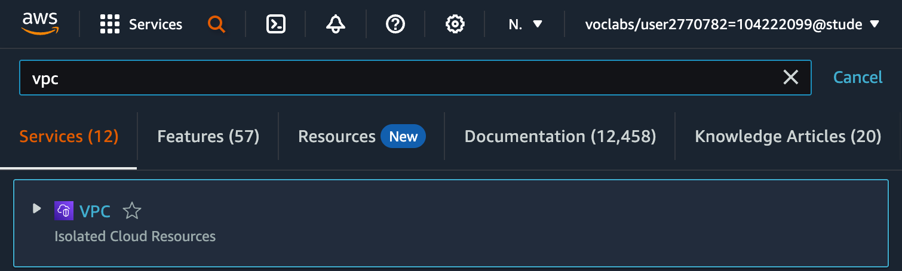

In the left navigation pane, under **Filter by VPC**, choose the **Select a VPC** box and select **Lab VPC**.

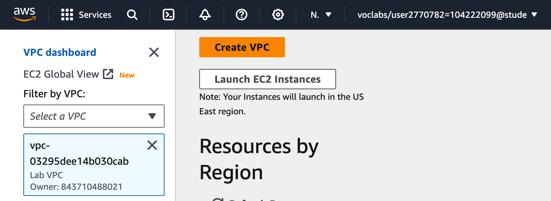

In the left navigation pane, choose **Your VPCs**.

Here, you can access information about the **Lab VPC** that was created for you. Choose **Lab VPC**.

In the **Details** tab, notice that the **IPv4 CIDR** field has a value of *10.0.0.0/16*, which means that this VPC includes all IP addresses that start with *10.0.x.x*.

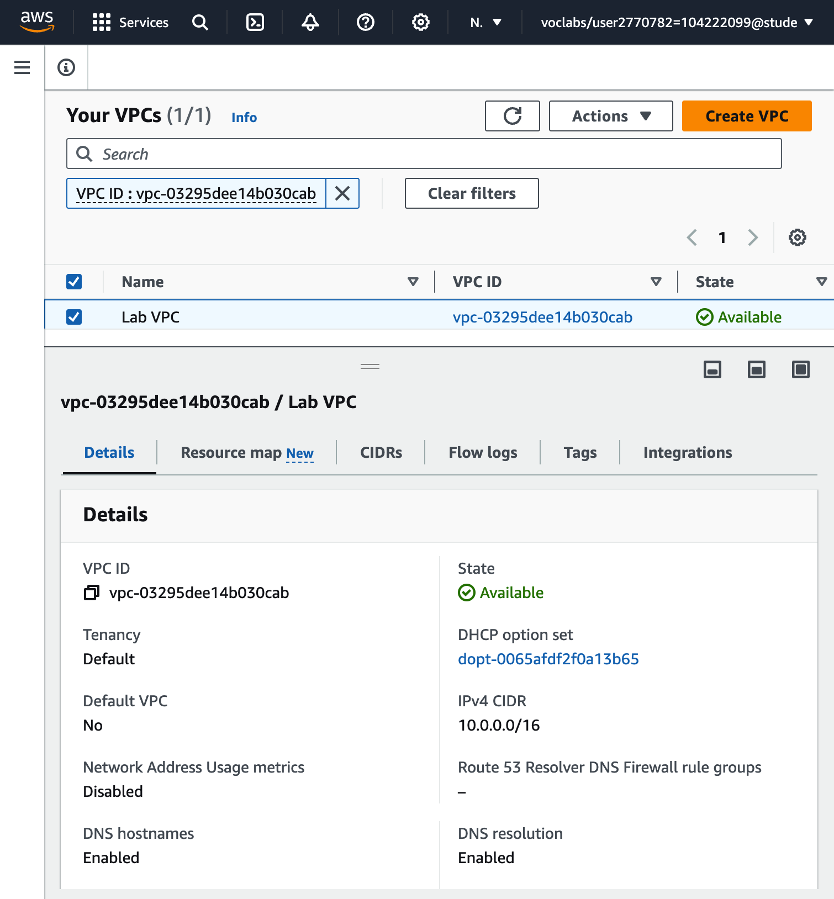

In the left navigation pane, choose **Subnets**.

Here, you can access information about **Public Subnet 1**. In the list of subnets view:

* The **VPC** column for Public Subnet 1 shows that this subnet exists inside of *Lab VPC*.
* The **IPv4 CIDR** column has a value of *10.0.0.0/24*, which means that this subnet includes the 256 IP addresses between *10.0.0.0* and *10.0.0.255*. Five of these addresses are reserved and unusable.
* The **Availability Zone** column lists the Availability Zone where this subnet resides.

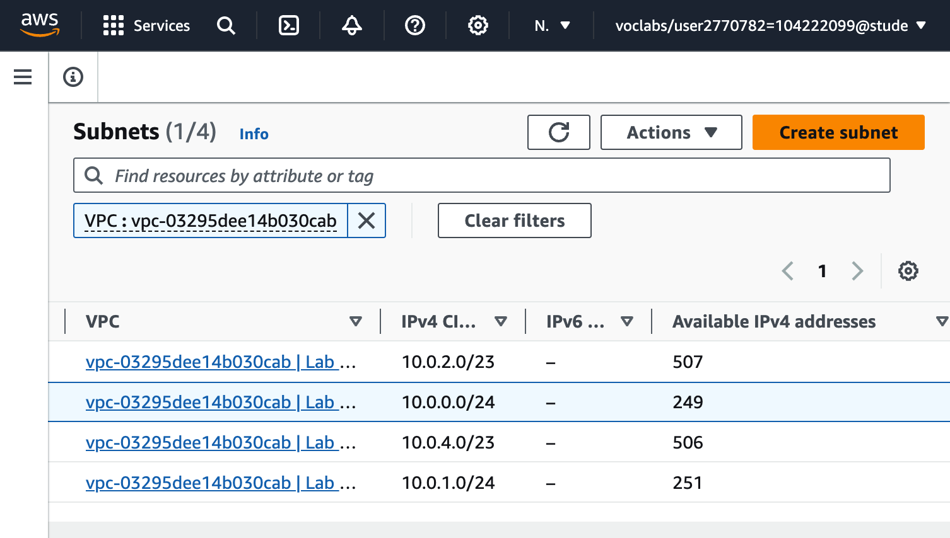

To reveal more details select **Public Subnet 1**.

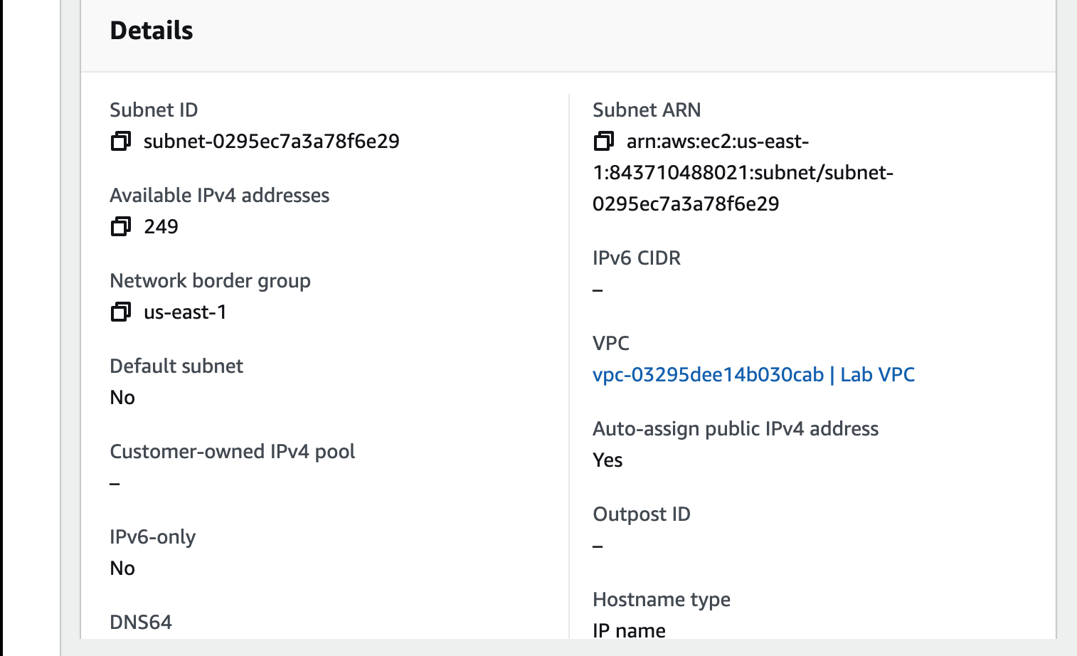

In the lower half of the page, choose the **Route table** tab.

This tab includes details about the routing for this subnet:

* The first entry specifies that traffic destined within the Classless Inter-Domain Routing (CIDR) range for the VPC (*10.0.0.0/16*) will be routed within the VPC (*local*).
* The second entry specifies that any traffic destined for the internet (*0.0.0.0/0*) is routed to the internet gateway (*igw-*) that exists in Lab VPC. This setting makes the subnet a *public subnet*.

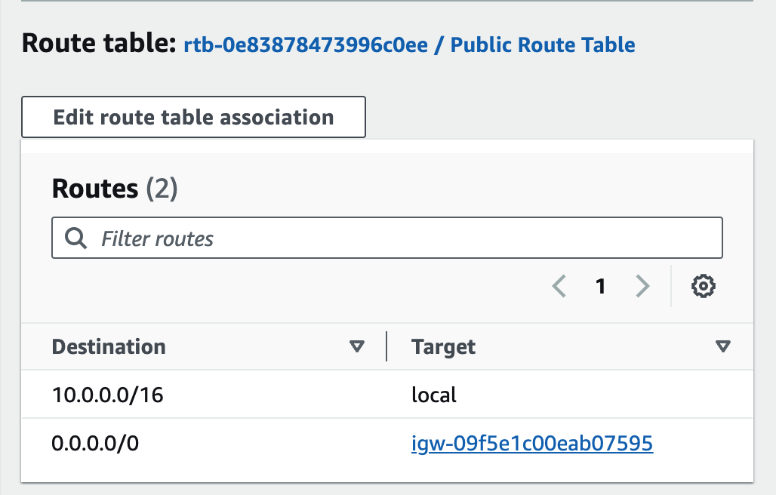

Choose the **Network ACL** tab.

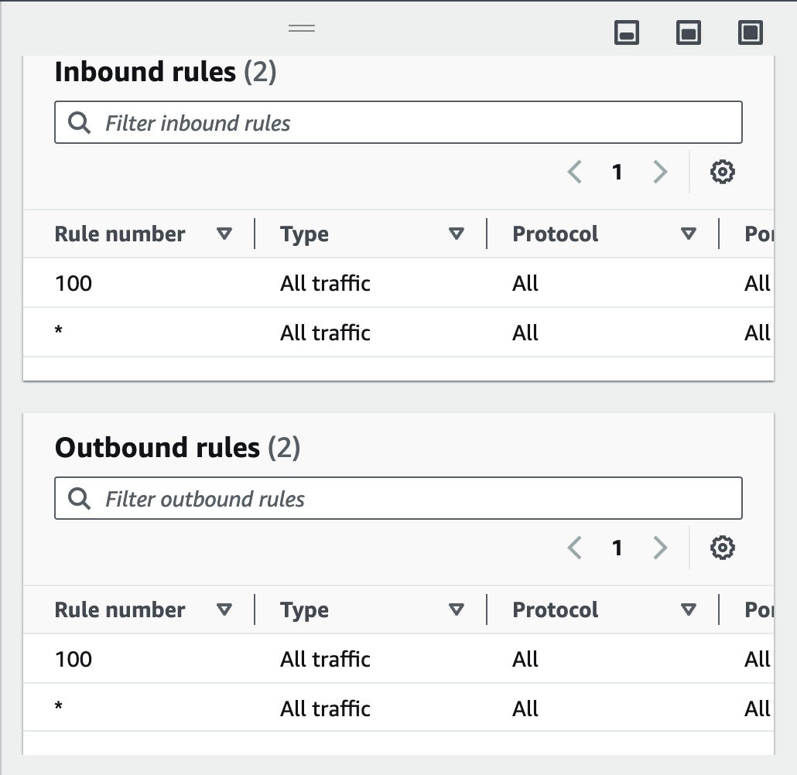

In the left navigation pane, choose **Internet gateways**.

Notice that an internet gateway with the name **Lab IG** is already attached to **Lab VPC**.

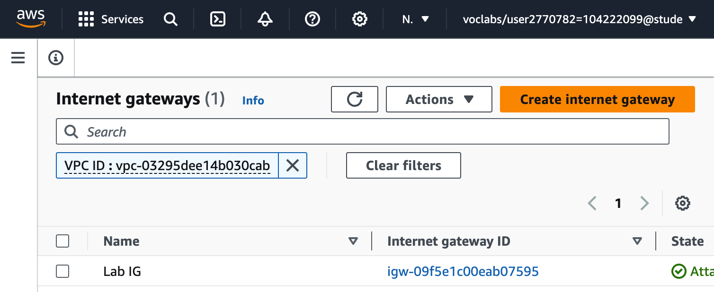

In the left navigation pane, choose **Security groups**.

Select **Inventory-DB**.

In the lower half of the page, choose the **Inbound rules** tab.

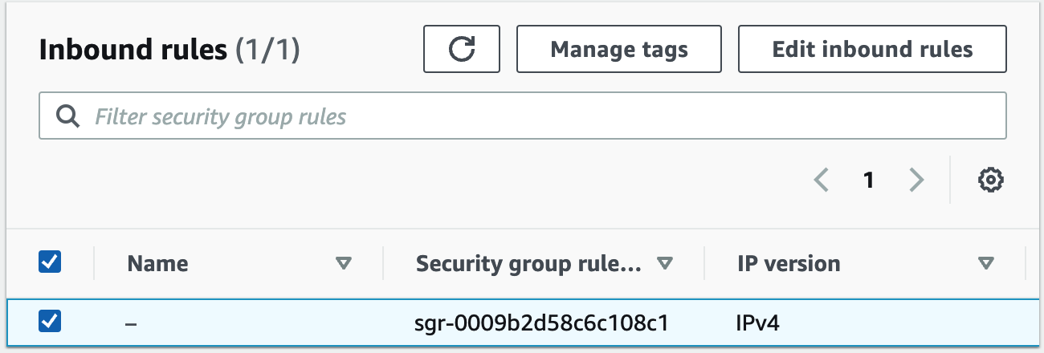

Choose the **Outbound rules** tab.

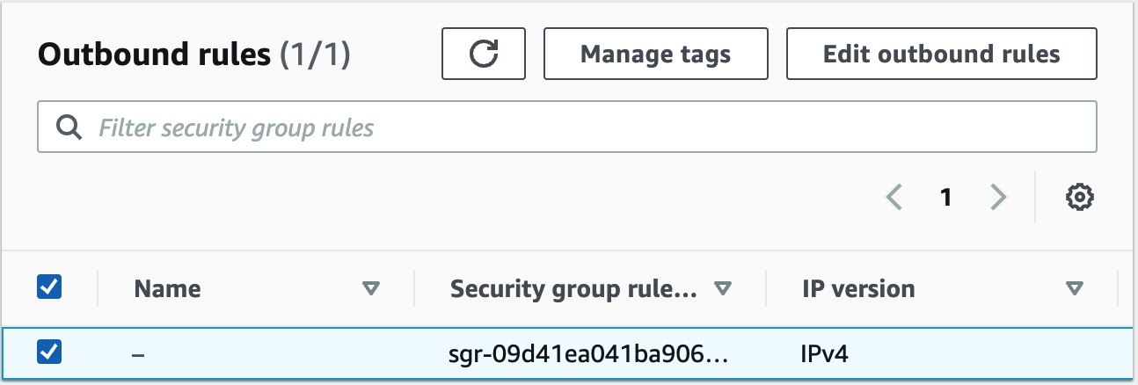

**Task 2: Creating an Application Load Balancer**

On the Services menu, choose **EC2**.

In the left navigation pane, choose **Load Balancers**.

Choose Create load balancer

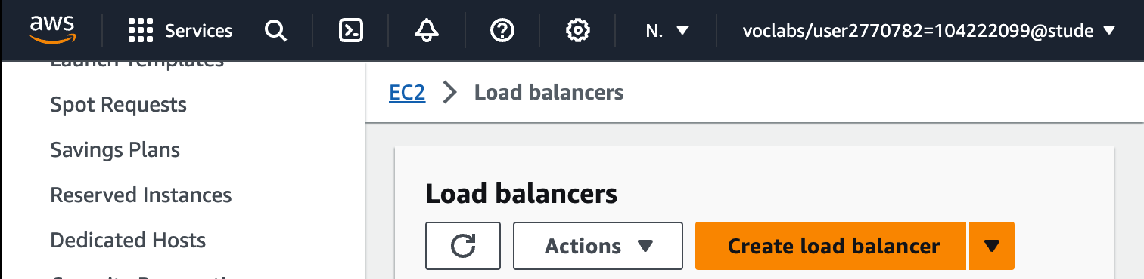

Under **Application Load Balancer**, choose **Create**.

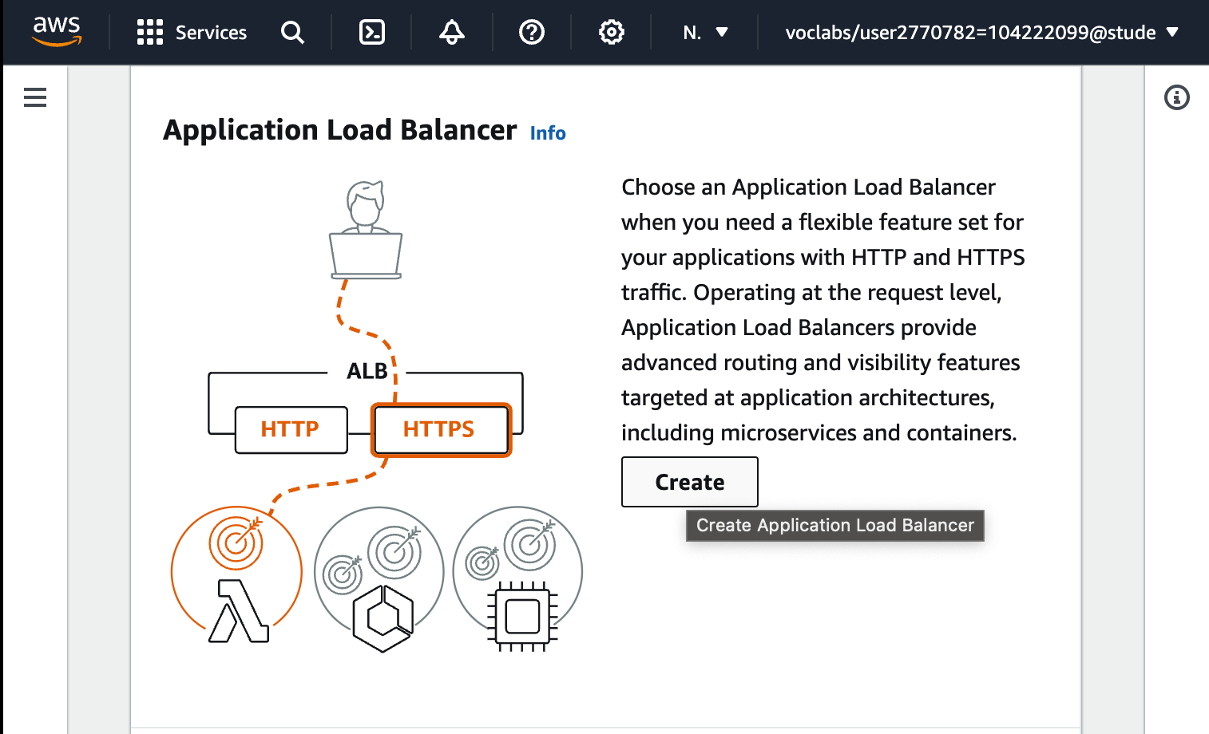

For **Load balancer name**, enter: Inventory-LB

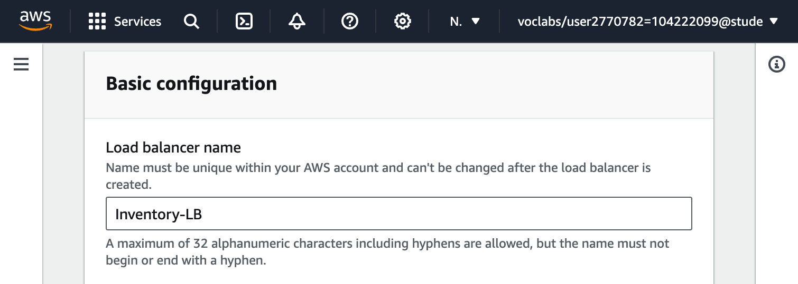

Scroll down to the **Network mapping** section, then for **VPC**, select **Lab VPC**.

**Important:** Be sure to choose **Lab VPC**. It is likely not the default selection.

Under **Mappings**, choose the **first** Availability Zone, then choose the **Public Subnet** that displays.

Choose the **second** Availability Zone, then choose the **Public Subnet** that displays.

You should now have selected two subnets: **Public Subnet 1** and **Public Subnet 2**. (If not, go back and try the configuration again.)

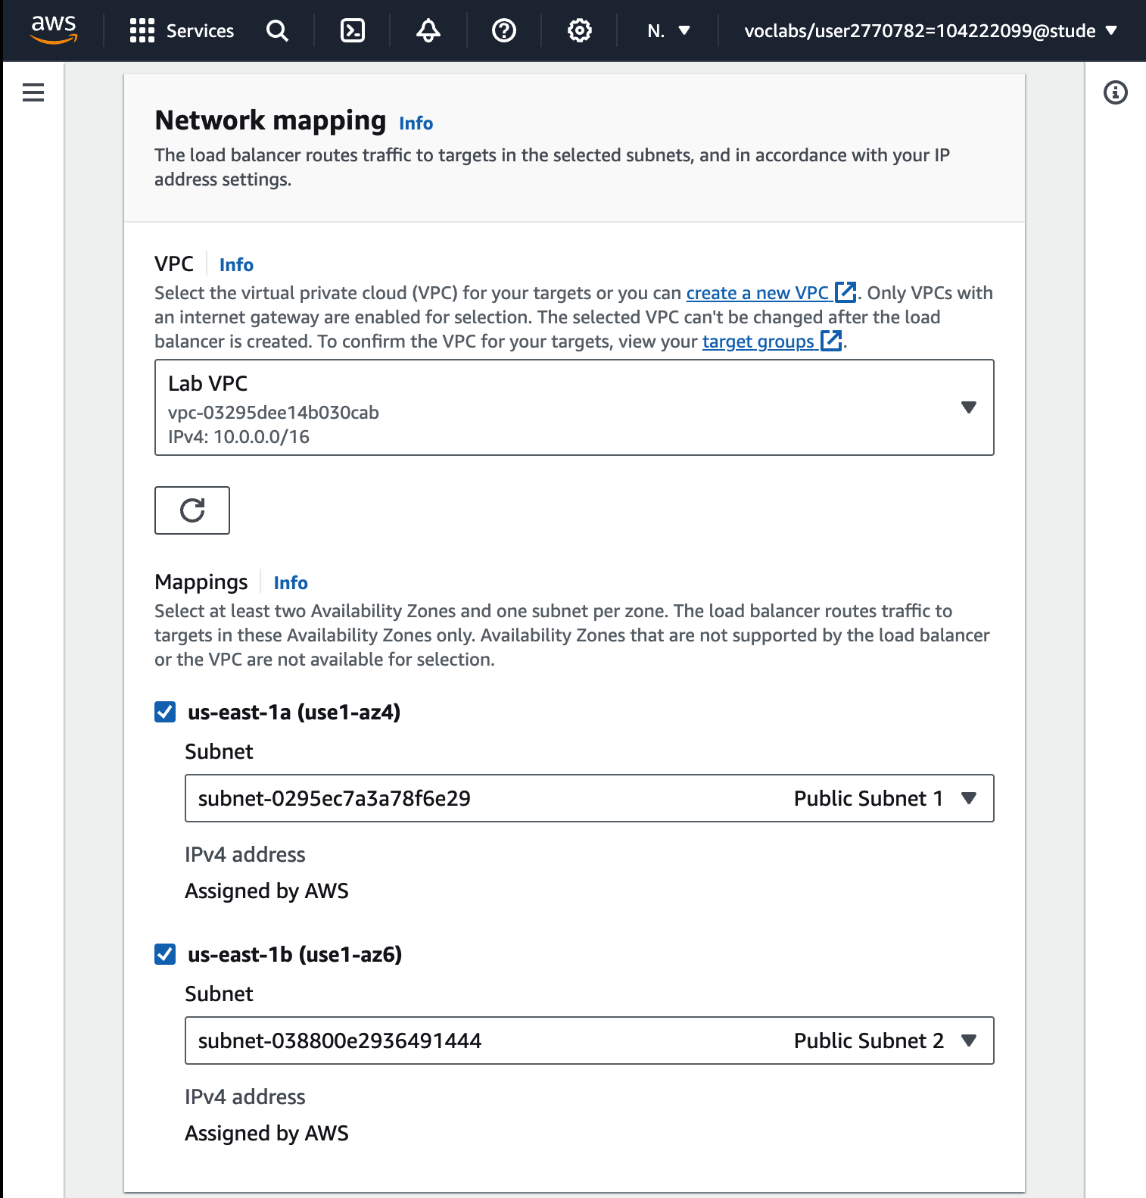

In the **Security groups** section, select the **Create a new security group** hyperlink. This opens a new browser tab. Configure the new security group settings:

* + **Security group name:** Inventory-LB
  + **Description:** Enable web access to load balancer
  + **VPC**: Remove the default VPC by choosing the X to the right of it. Then select **Lab VPC**.

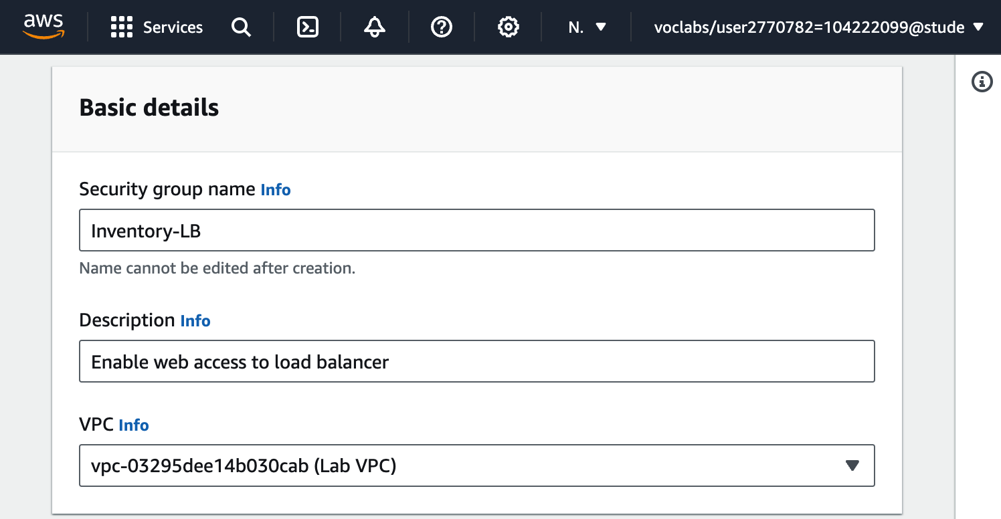

Under **Inbound rules**, choose **Add rule** and configure as described:

* + **Type:** *HTTP*
  + **Source:** *Anywhere-IPv4*

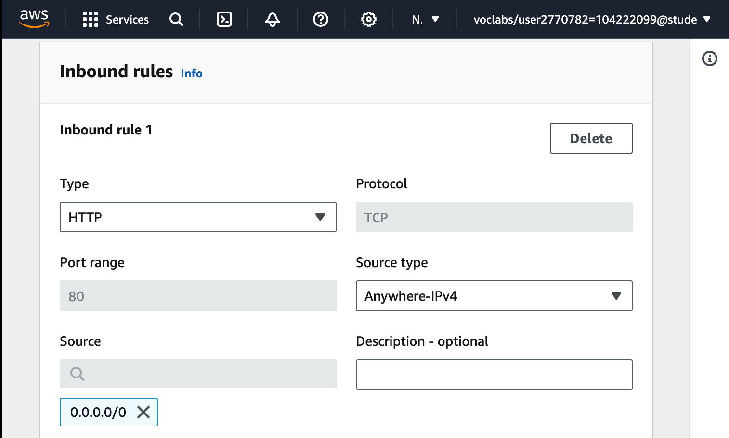

Still under **Inbound rules**, choose **Add rule** again and configure:

* + **Type:** *HTTPS*
  + **Source:** *Anywhere-IPv4*

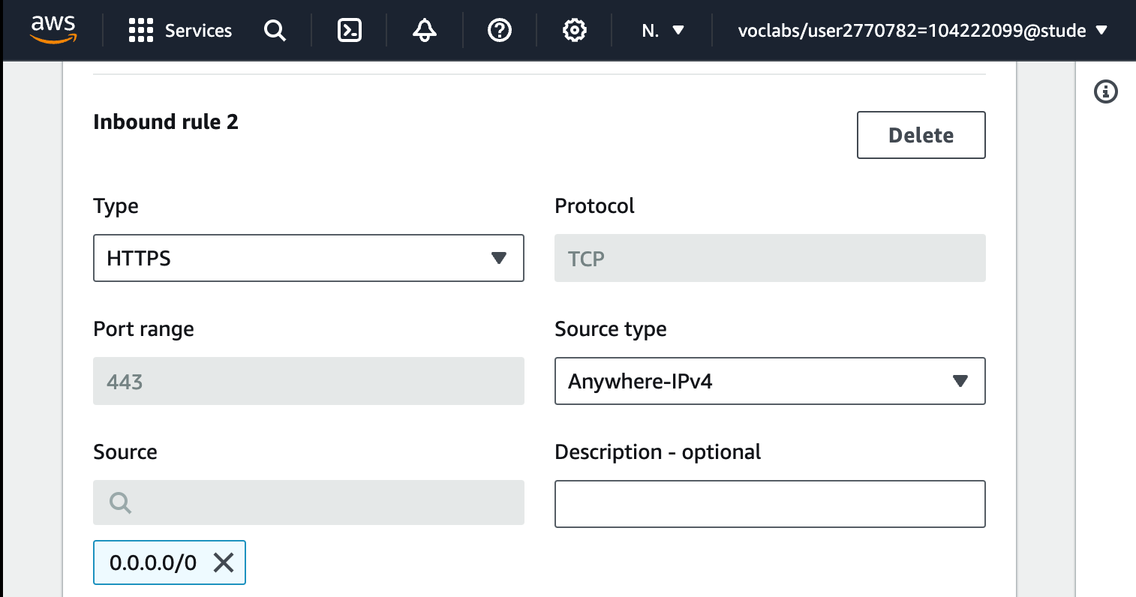

Assign the security group to the load balancer:

* + Return to the browser tab where you are still configuring the load balancer.
  + In the **Security groups** area and choose the refresh icon.
  + For **Security groups**, select the **Inventory-LB** security group you just created.
  + Next, below the **Security groups** dropdown menu, select the **X** next to the *default* security group so that Inventory-LB is now the only security group chosen.

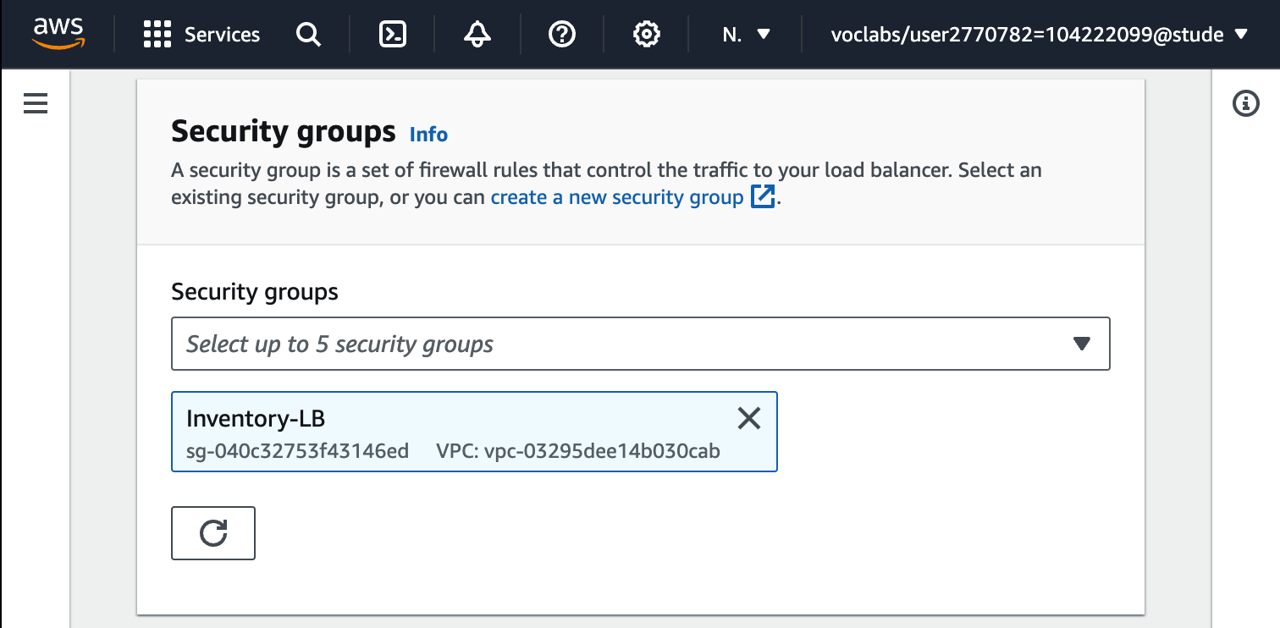

In the **Listeners and routing** section, choose **Create target group**.

Configure the target group as described here:

* **Choose a target type:** *Instances*
* **Target group name:** Inventory-App
* **VPC:** Ensure that *Lab VPC* is chosen.
* Scroll down and expand **Advanced health check settings**.
* **Healthy threshold:** 2
* **Interval:** 10 (seconds)
* Choose **Next**. The *Register targets* screen appears.
* Review the settings and choose **Create target group**.

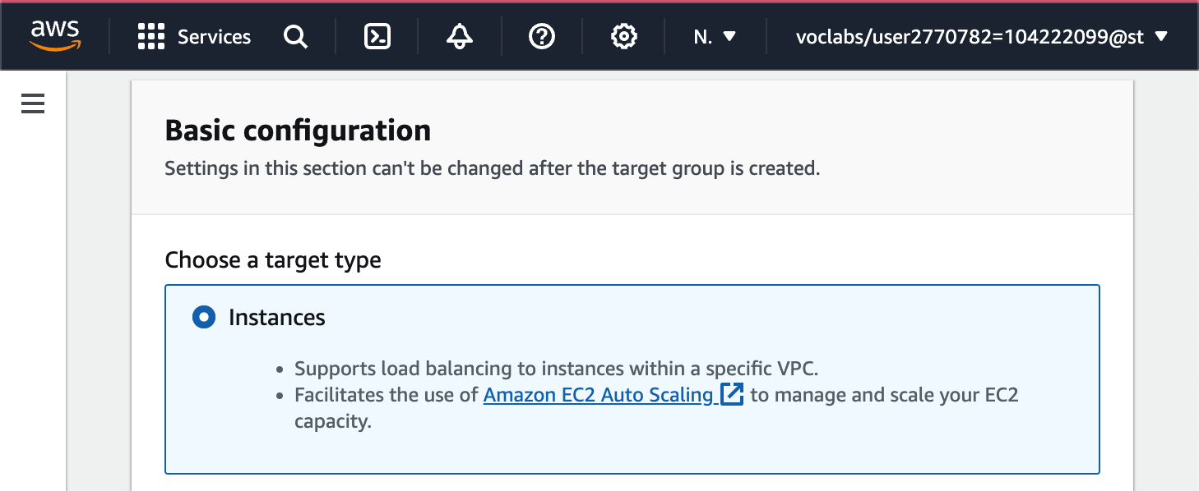

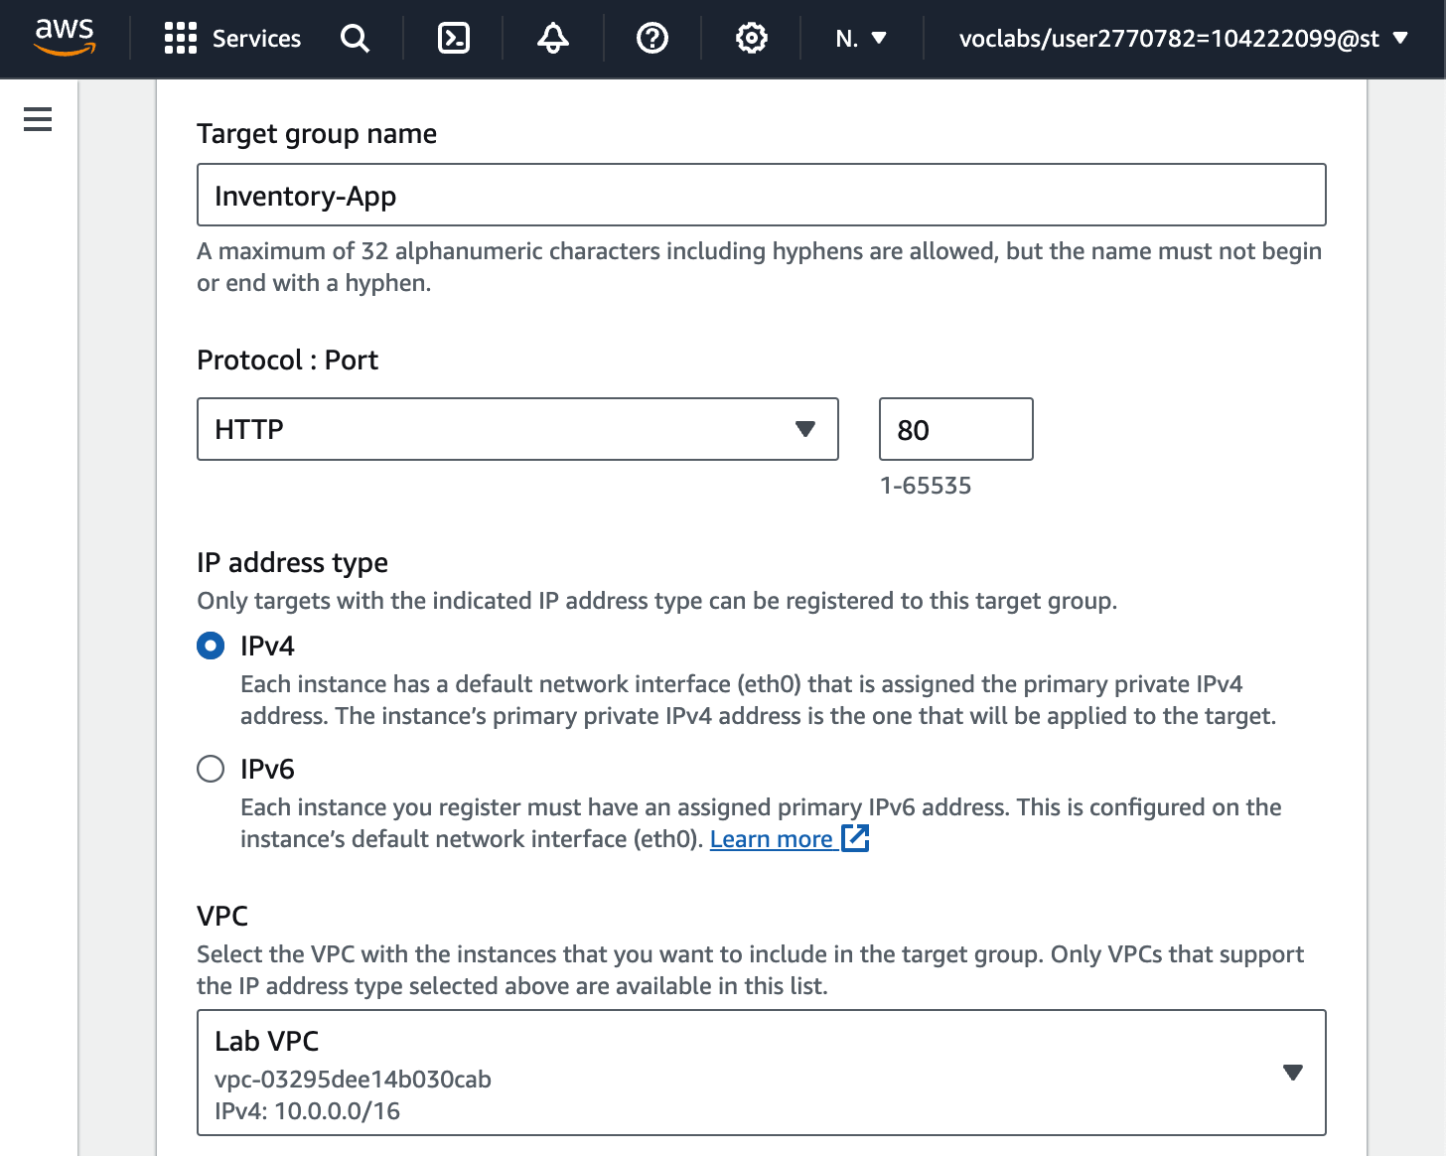

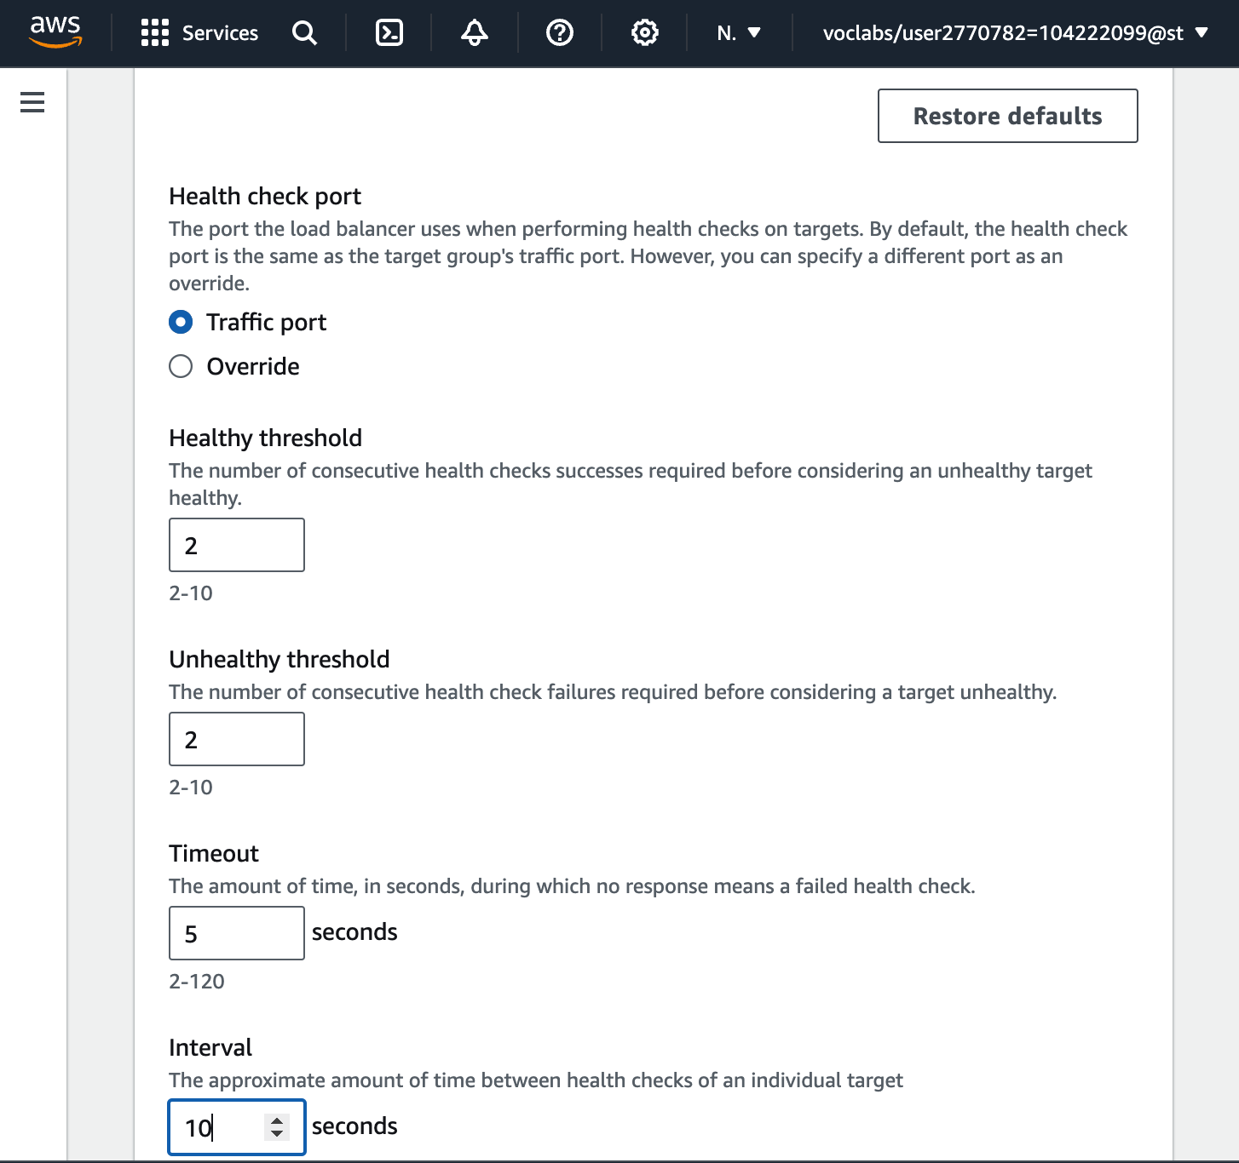

Return to the browser tab where you already started defining the load balancer.

In the **Listeners and routing** section, choose the refresh icon.

For the **Listener HTTP:80** row, set the **Default action** to forward to the **Inventory-App** target group you just created.

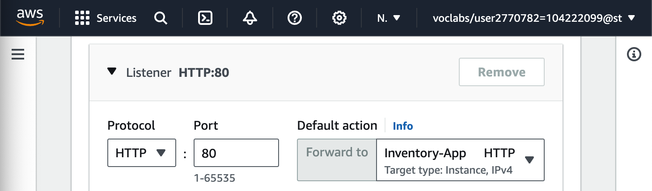

Scroll to the bottom of the page, and choose **Create load balancer**.

* + The load balancer is successfully created.
  + Choose **View load balancer**.

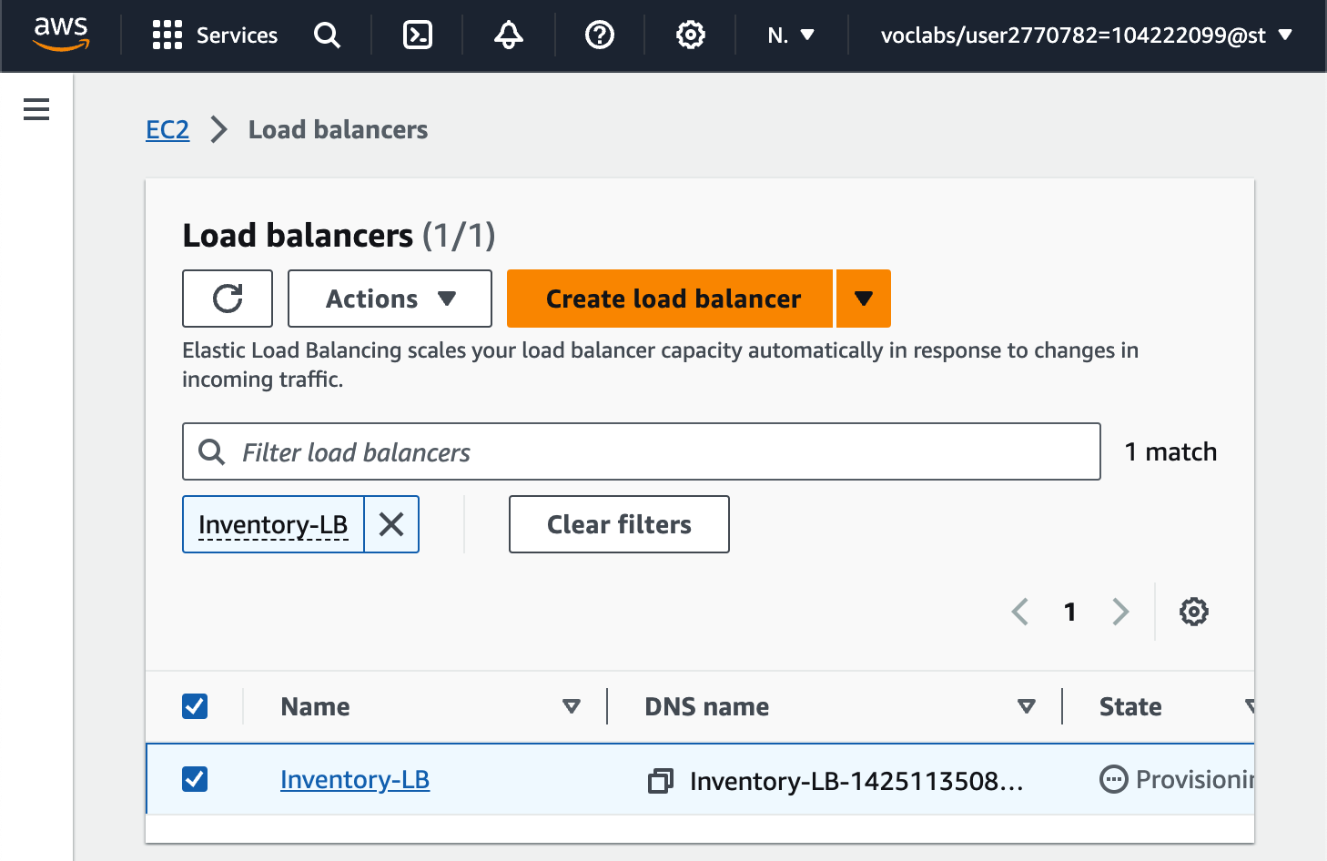

**Task 3: Creating an Auto Scaling group**

**Create an AMI for Auto Scaling**

In the **AWS Management Console**, on the Services menu, choose **EC2**.

In the left navigation pane, choose **Instances**.

Wait until the **Status check** for **Web Server 1** displays *2/2 checks passed*. Choose refresh to update.

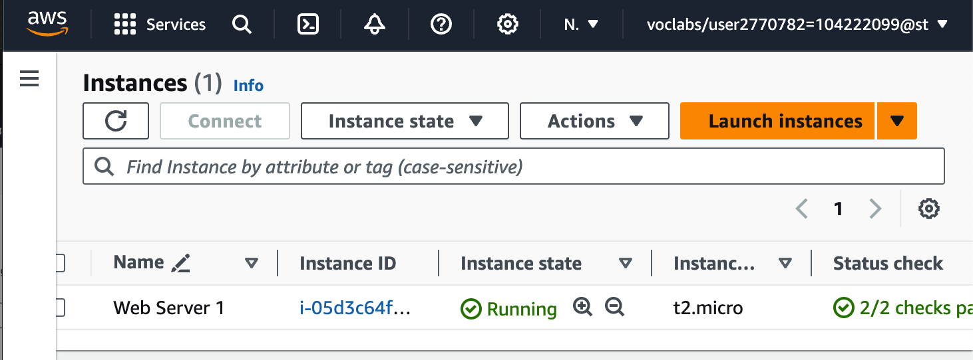

Select **Web Server 1**.

In the Actions menu, choose **Image and templates** > **Create image**, then configure:

* + **Image name:** Web Server AMI
  + **Image description:** Lab AMI for Web Server

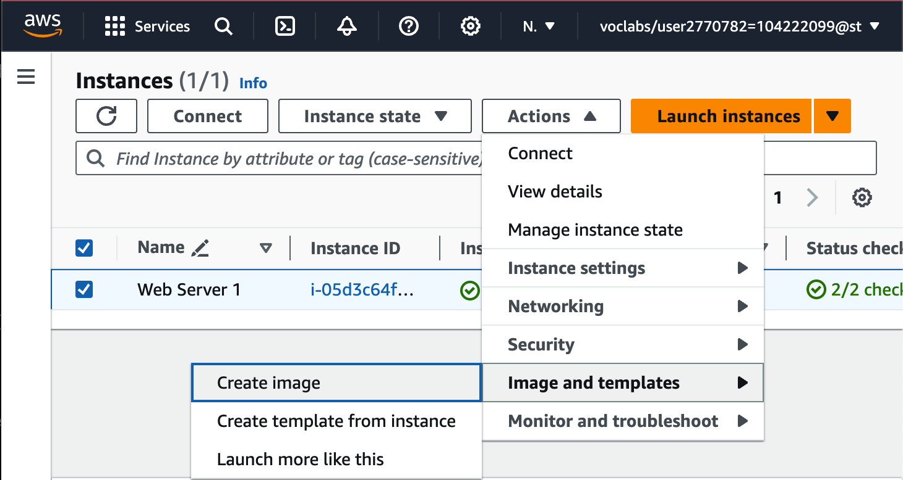

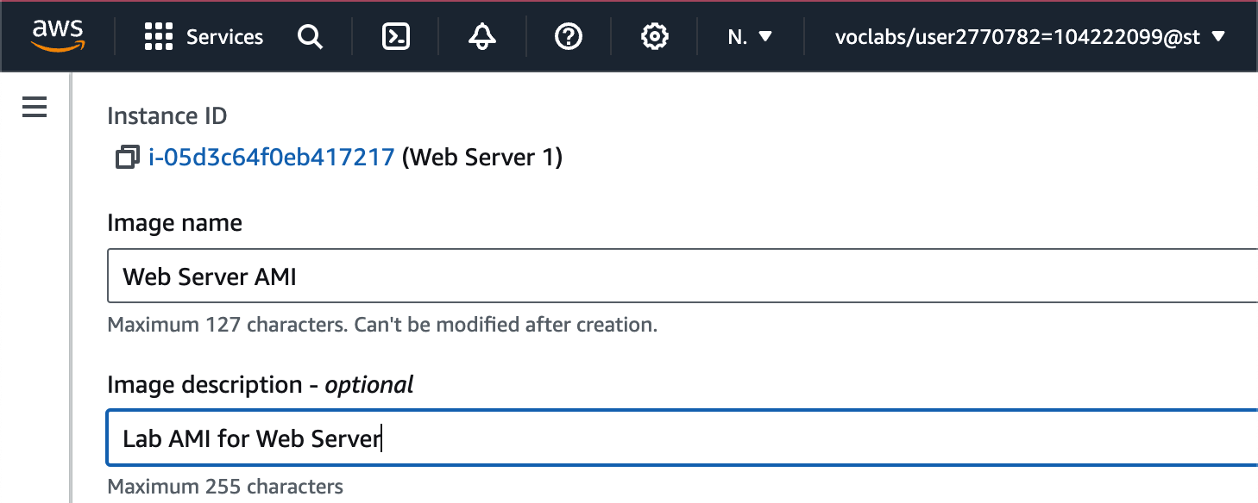

Choose Create image

A banner at the top of the screen displays the **AMI ID** for your new AMI.

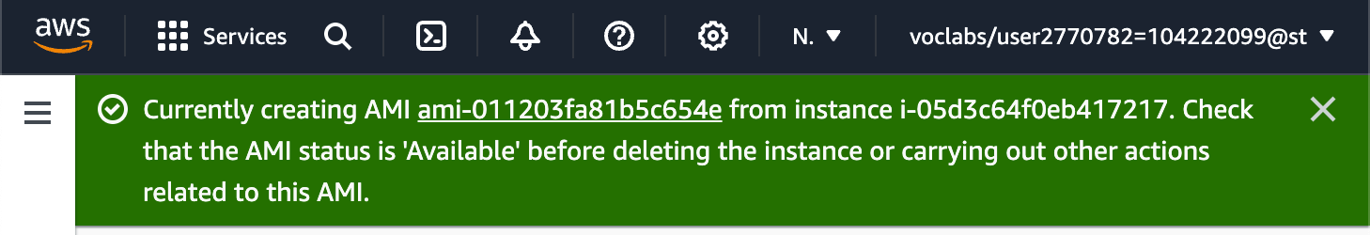

**Create a Launch Template and an Auto Scaling Group**

In the left navigation pane, choose **Launch Templates**.

Choose Create launch template

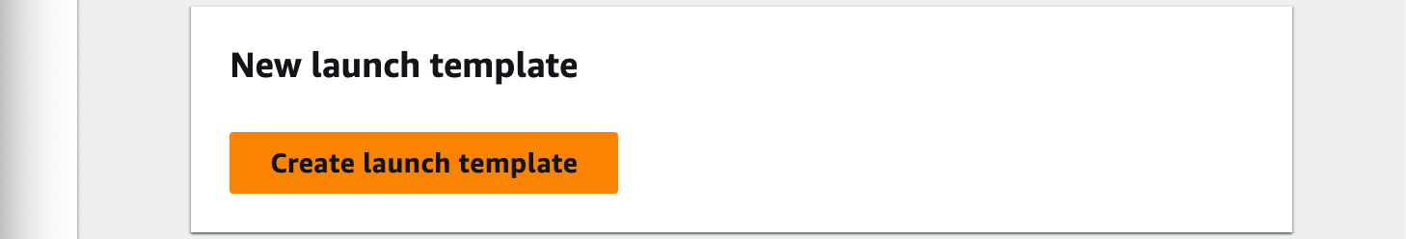

Configure the launch template settings and create it:

* **Launch template name:** Inventory-LT
* Under **Auto Scaling guidance**, select *Provide guidance to help me set up a template that I can use with EC2 Auto Scaling*

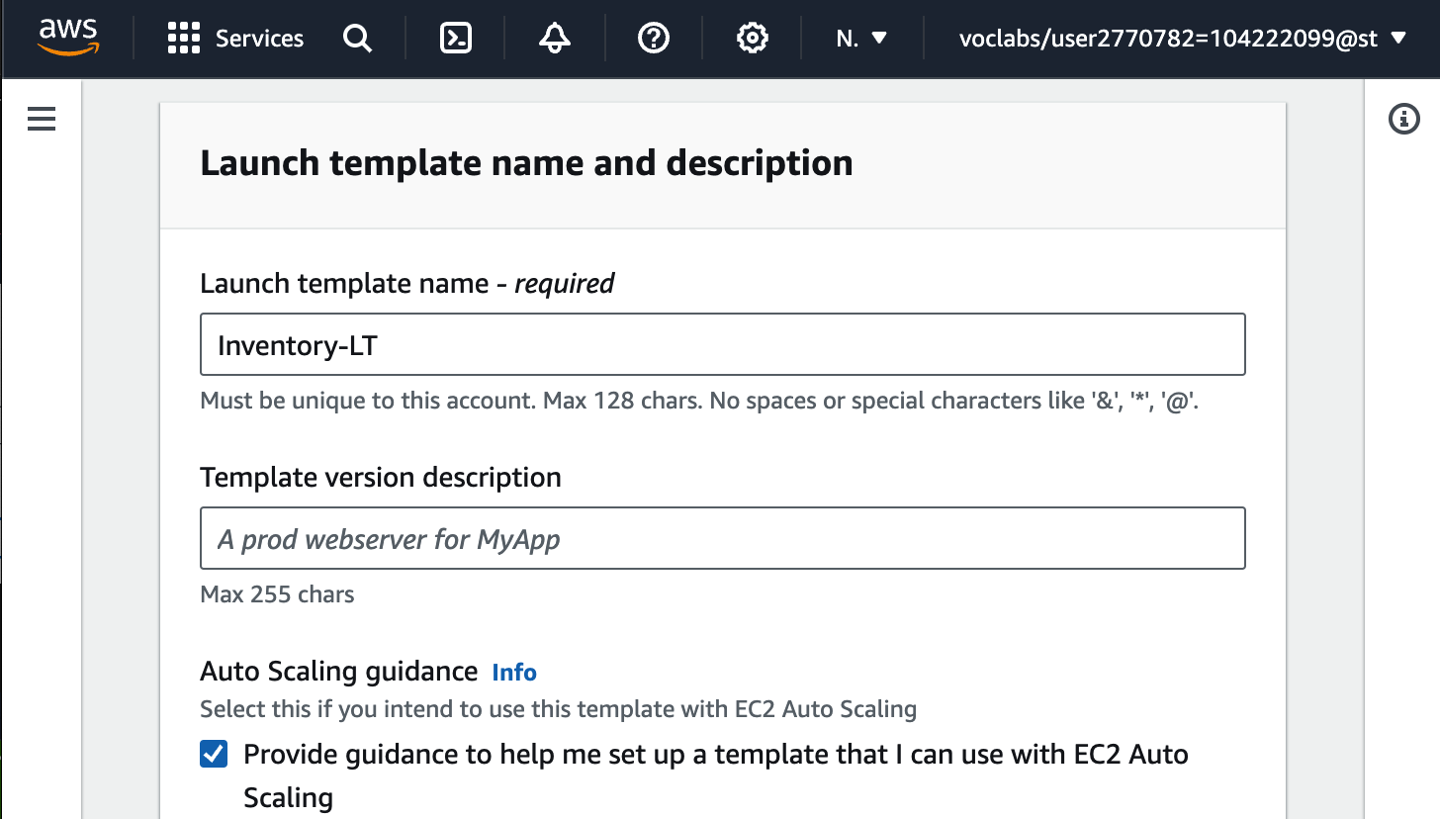

* In the Application and OS Images (Amazon Machine Image) area, choose *My AMIs*.
* **Amazon Machine Image (AMI)**: choose *Web Server AMI*

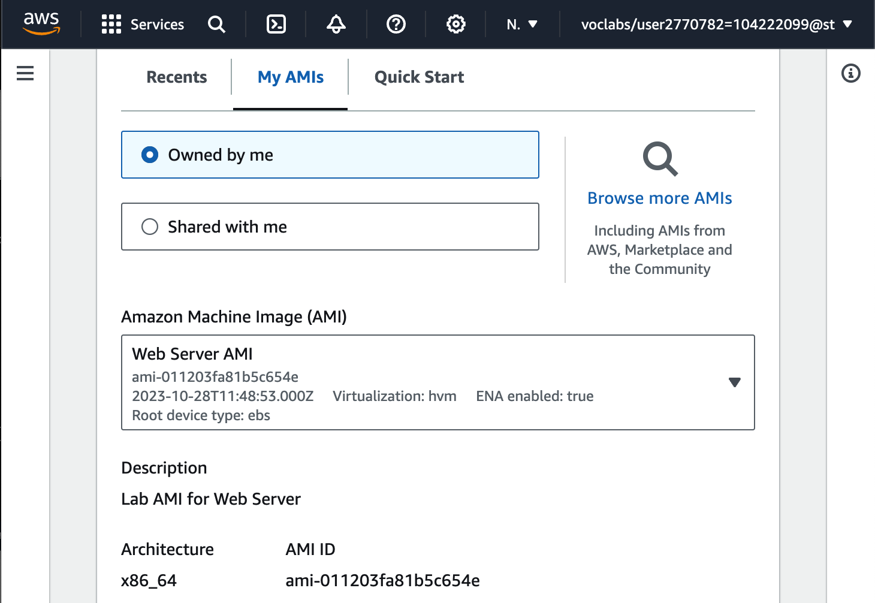

* **Instance type:** choose *t2.micro*
* **Key pair name**: choose *vockey*

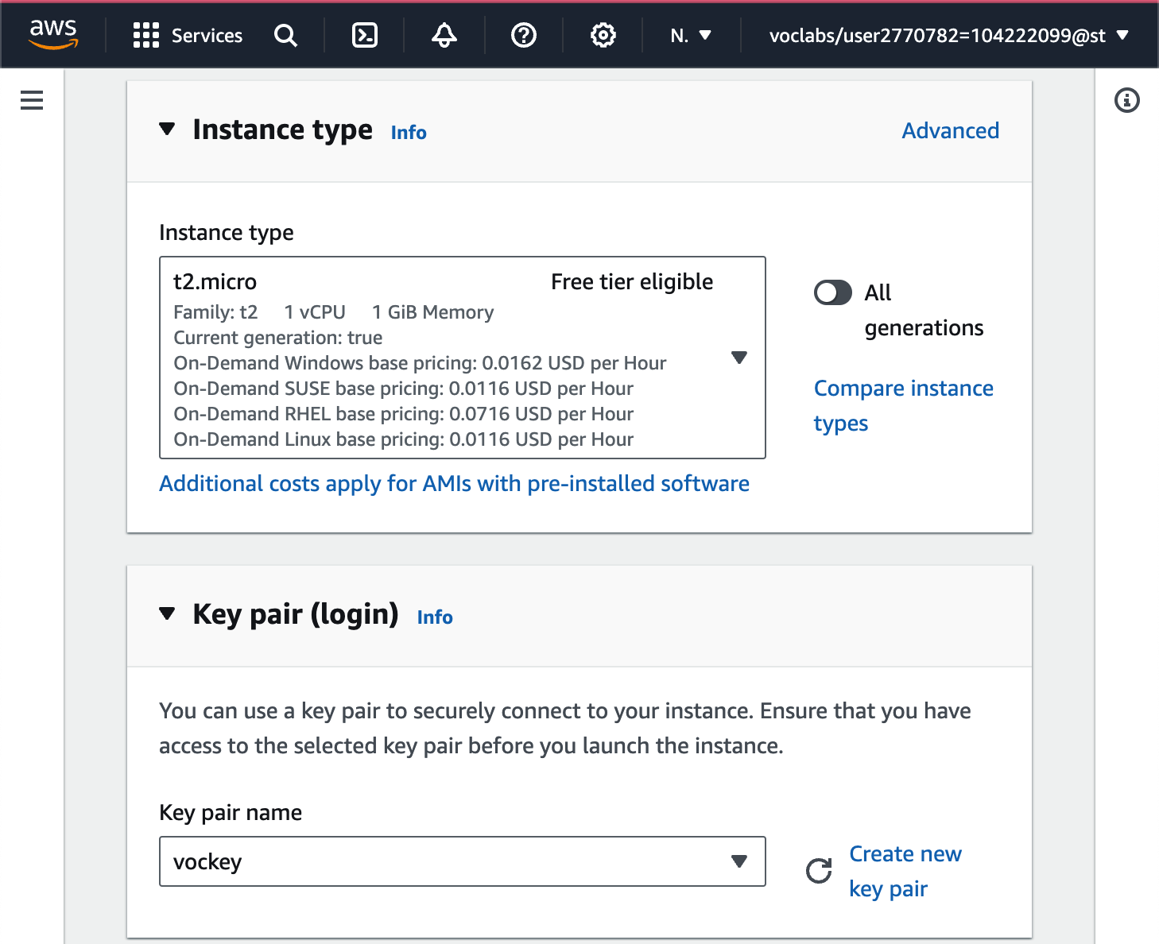

* **Firewall (security groups)**: choose *Select existing security group*
* **Security groups**: choose *Inventory-App*

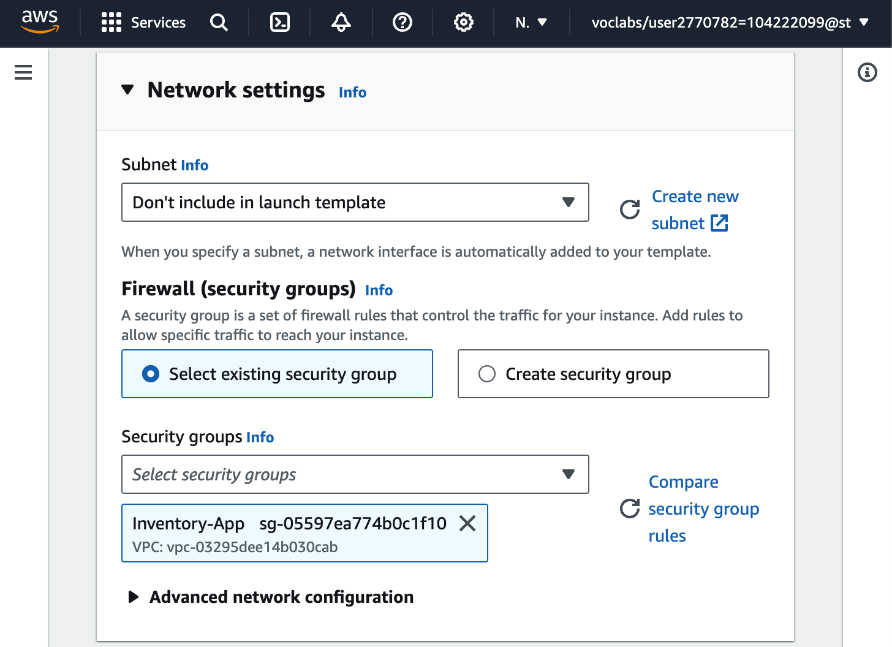

* Scroll down to the **Advanced details** area and expand it.
* **IAM instance profile**: choose *Inventory-App-Role*

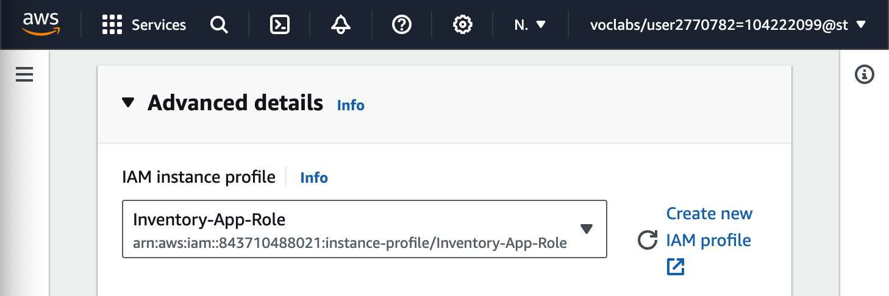

* Scroll down to the **Detailed CloudWatch monitoring** setting. Select *Enable* Note: This will allow Auto Scaling to react quickly to changing utilization.

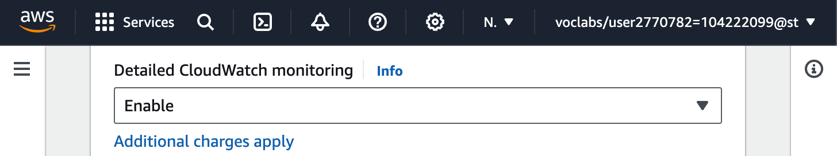

* Under **User data**, paste in the script below:

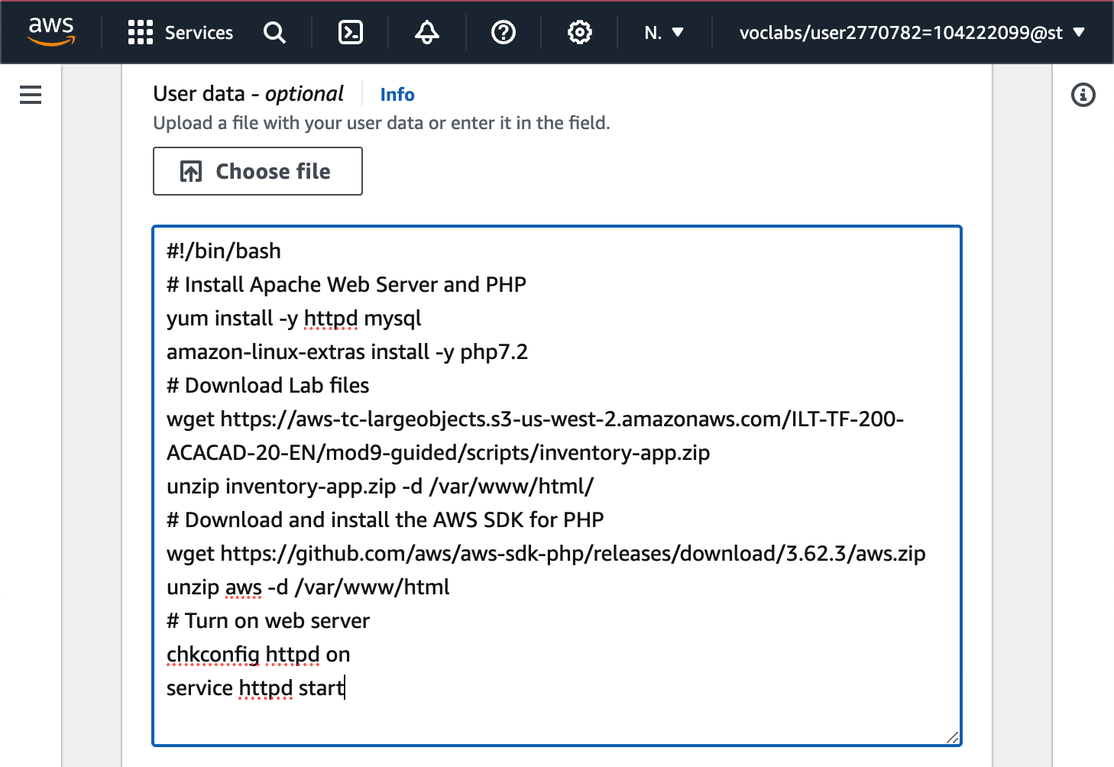

* Choose Create launch template

In the Success dialog, choose the **Inventory-LT** launch template.

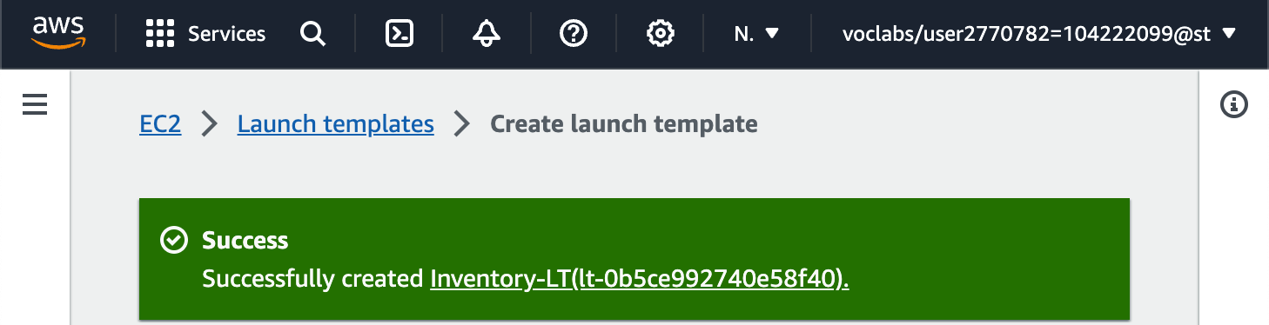

From the Actions menu, choose *Create Auto Scaling group*

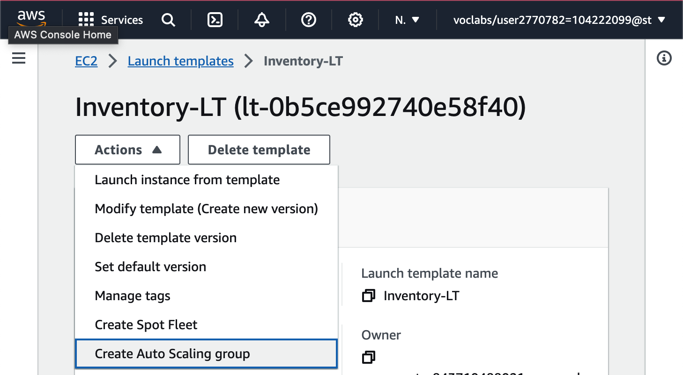

Configure the details in Step 1 (Choose launch template or configuration):

* **Auto Scaling group name:** Inventory-ASG (*ASG* stands for *Auto Scaling group*)
* **Launch template**: confirm that the *Inventory-LT* template you just created is selected.
* Choose Next

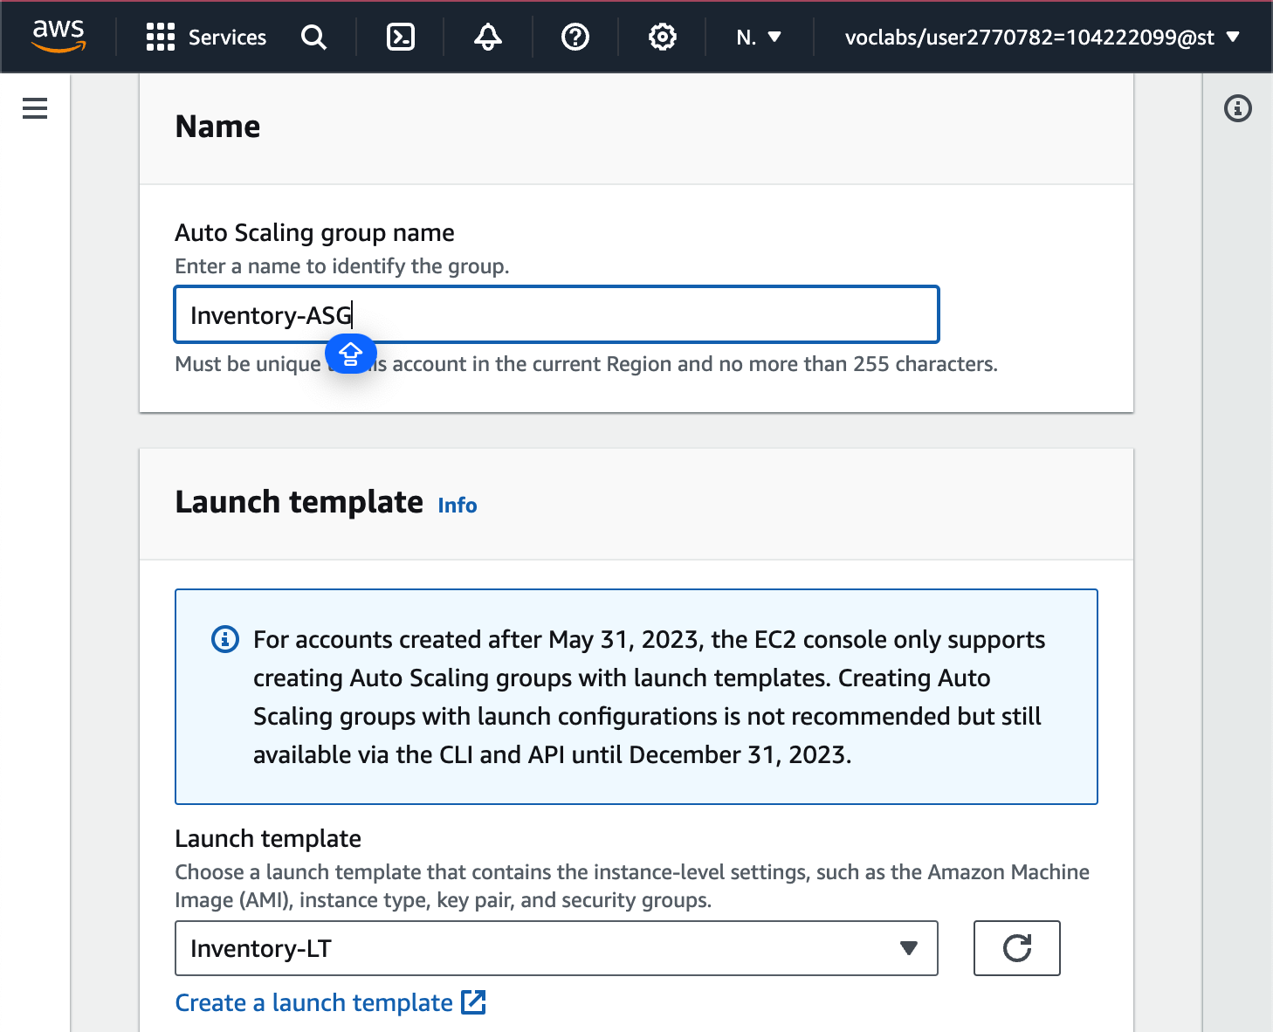

Configure the details in Step 2 (Choose instance launch options):

* **VPC**: choose *Lab VPC*
* **Availability Zones and subnets**: Choose *Private Subnet 1* and then choose *Private Subnet 2*. This will launch EC2 instances in private subnets across both Availability Zones.
* Choose Next

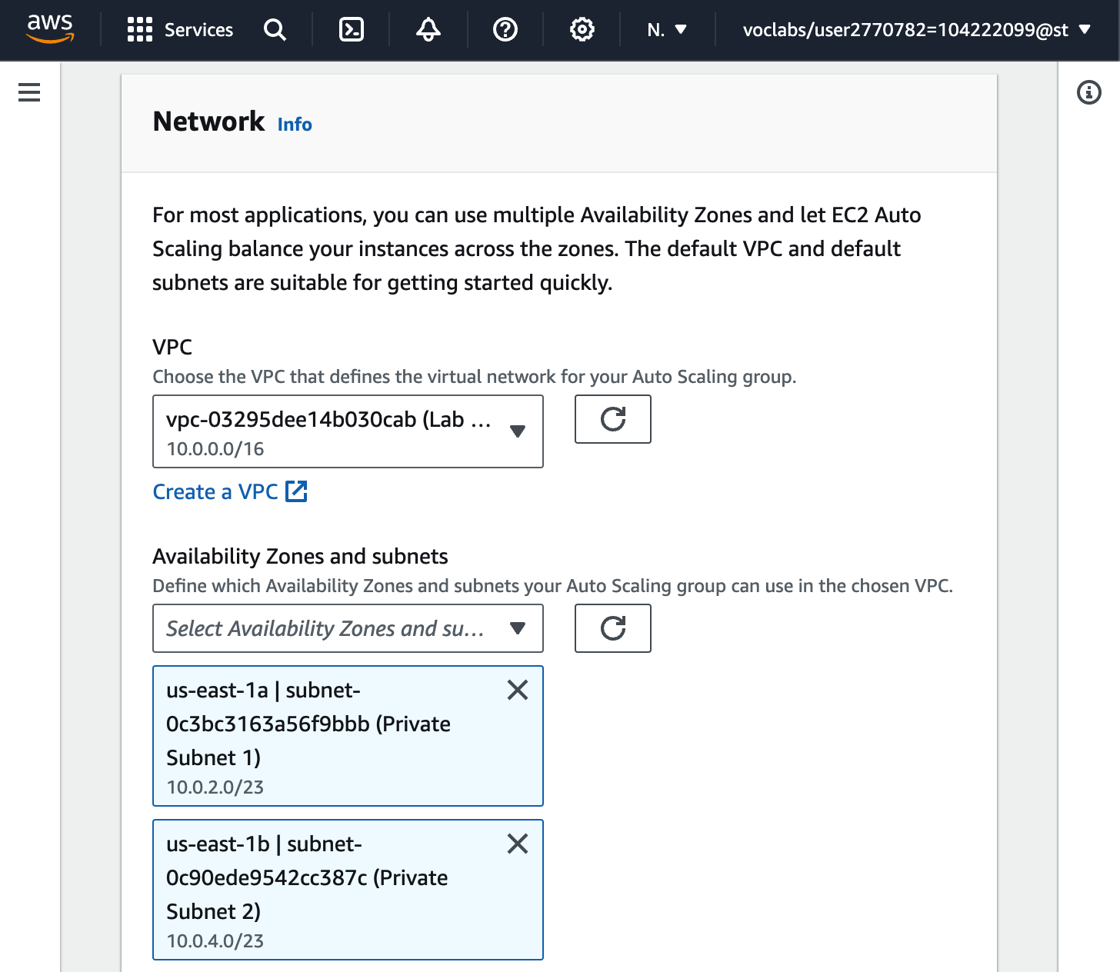

Configure the details in Step 3 (Configure advanced options):

* In the **Load balancing** panel:
  + Choose **Attach to an existing load balancer**
  + **Existing load balancer target groups**: select *Inventory-App*.

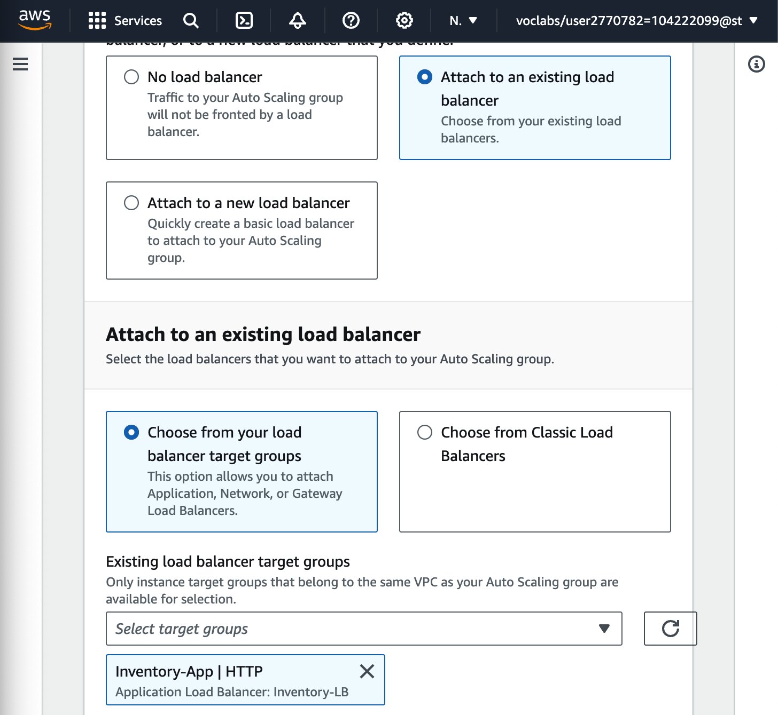

* In the **Health checks** panel:
  + **Health check grace period**: 90 seconds

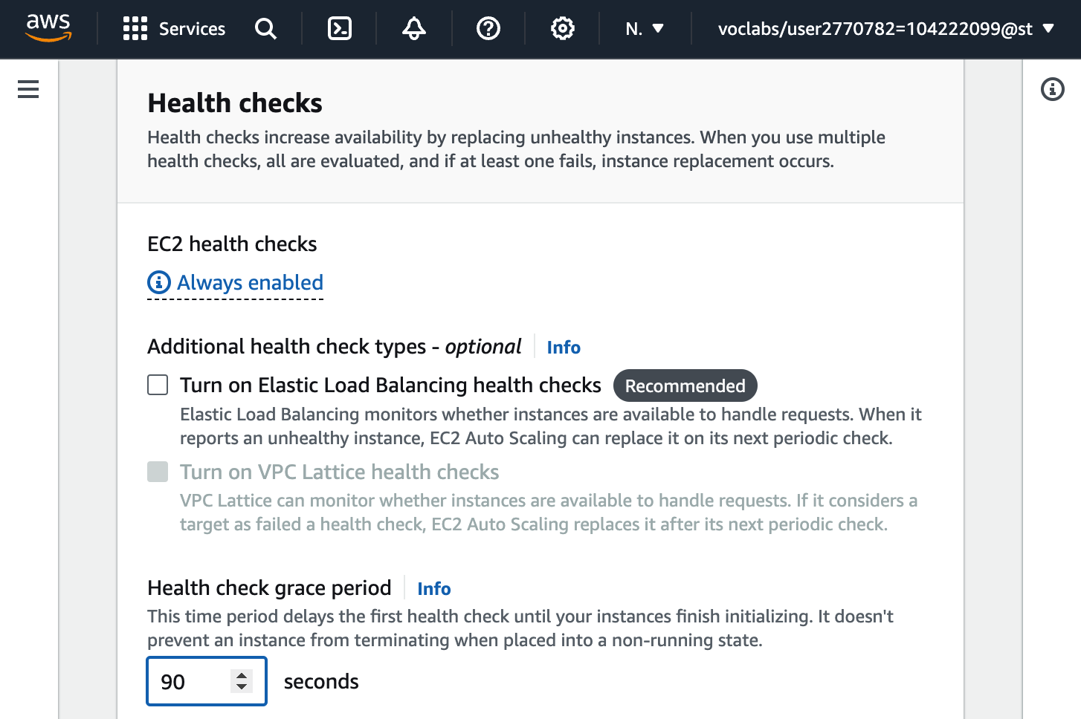

* In the **Additional settings** panel:
  + Select **Enable group metrics collection within CloudWatch**

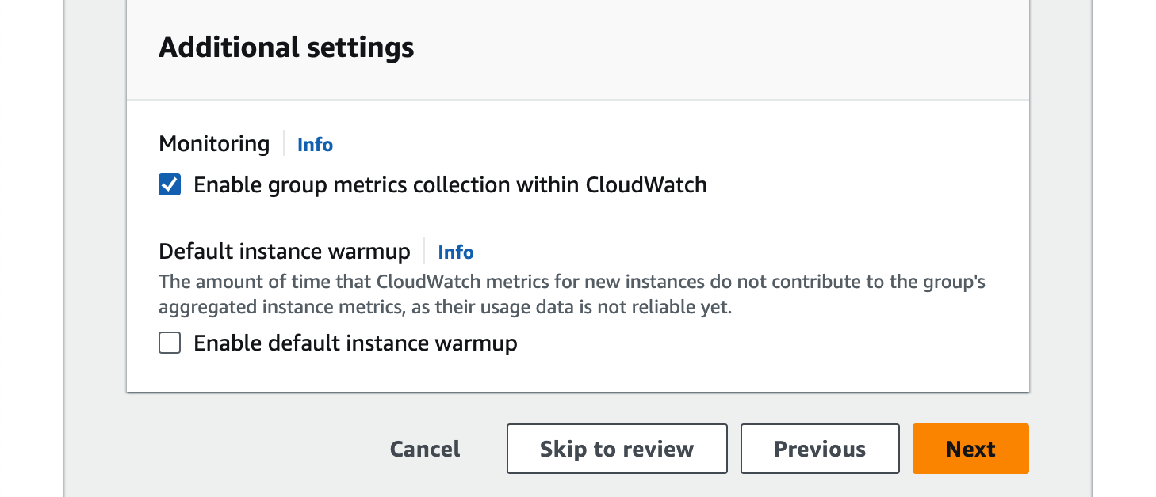

* Choose Next

Configure the details in Step 4 (Configure group size and scaling policies - optional):

* Under **Group size**, configure:
  + **Desired capacity:** 2
  + **Minimum capacity:** 2
  + **Maximum capacity:** 2

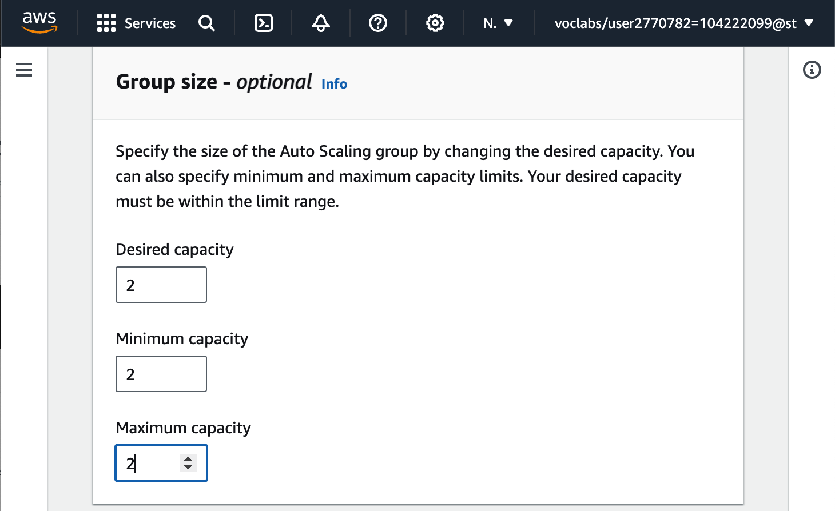

* Under **Scaling policies**, choose *None*

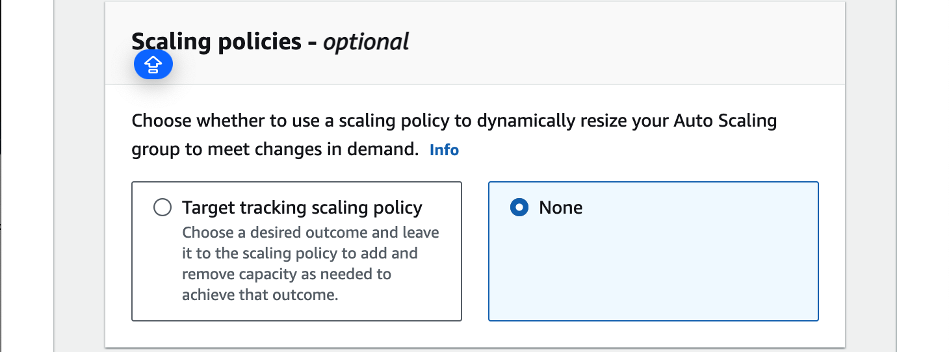

* Choose Next

Configure the details in Step 5 (Add notifications - optional):

You do not need to configure any of these settings.

Configure the details in Step 6 (Add tags - optional):

* Choose Add tag and Configure the following:
  + **Key:** Name
  + **Value:** Inventory-App
* Choose Next

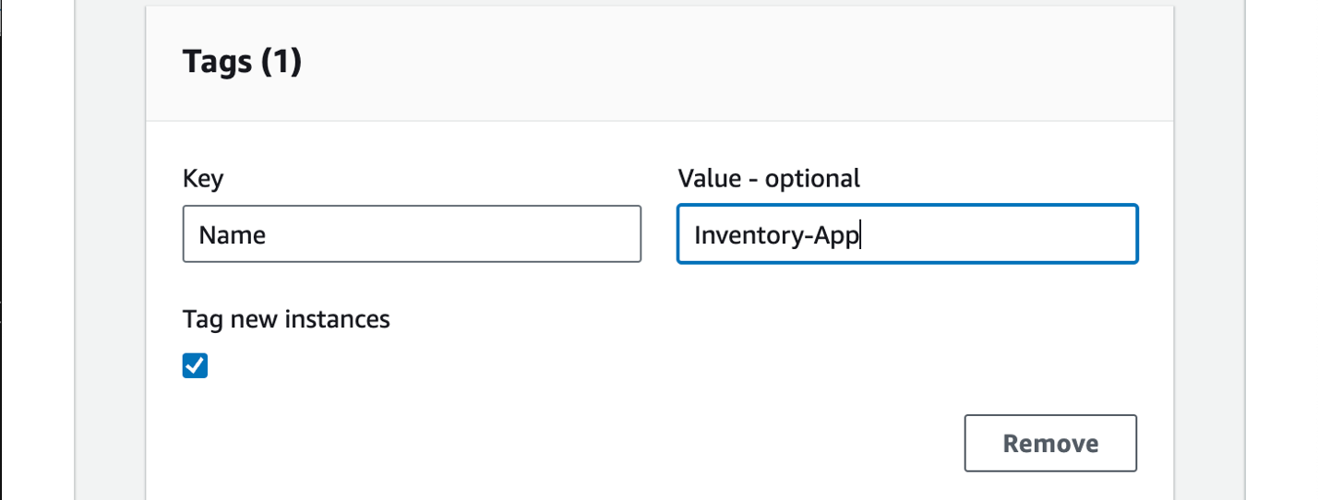

Configure the details in Step 6 (Review):

* Review the details of your Auto Scaling group
* At the bottom of the page, choose Create Auto Scaling group

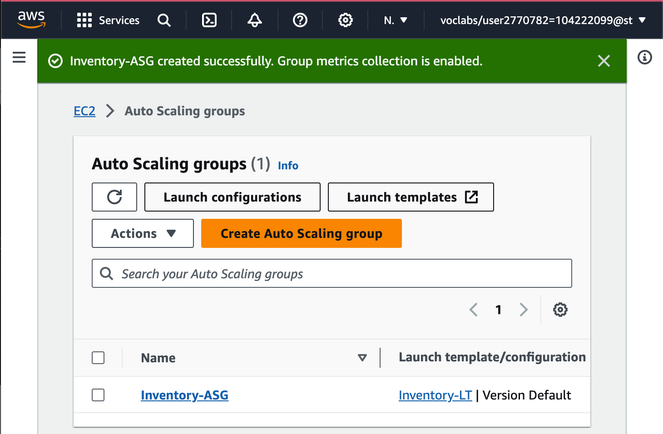

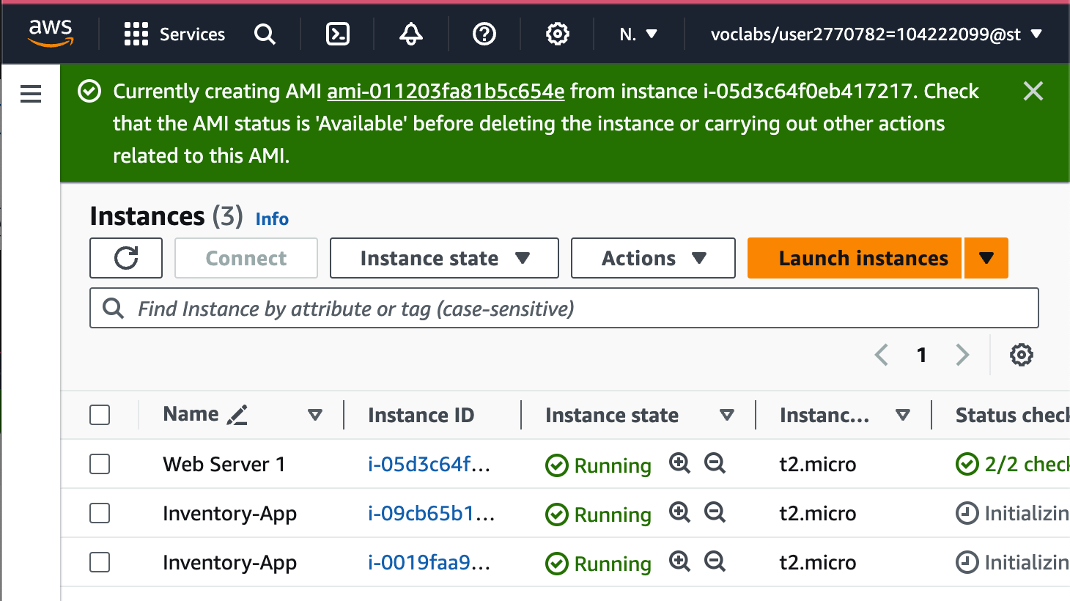

**Task 4: Updating security groups**

**Load balancer security group ( Already configured)**

**Application security group**

In the left navigation pane, choose **Security Groups**.

Select **Inventory-App**.

In the lower half of the page, choose the **Inbound rules** tab.

Choose Edit inbound rules.

On the **Edit inbound rules** page, choose Add rule and configure these settings:

* **Type:** *HTTP*
  + **Source:**
    - Choose the search box to the right of **Custom**
    - Delete the current contents
    - Enter sg
    - From the list that appears, select **Inventory-LB**
* **Description:** Traffic from load balancer
* Choose Save rules

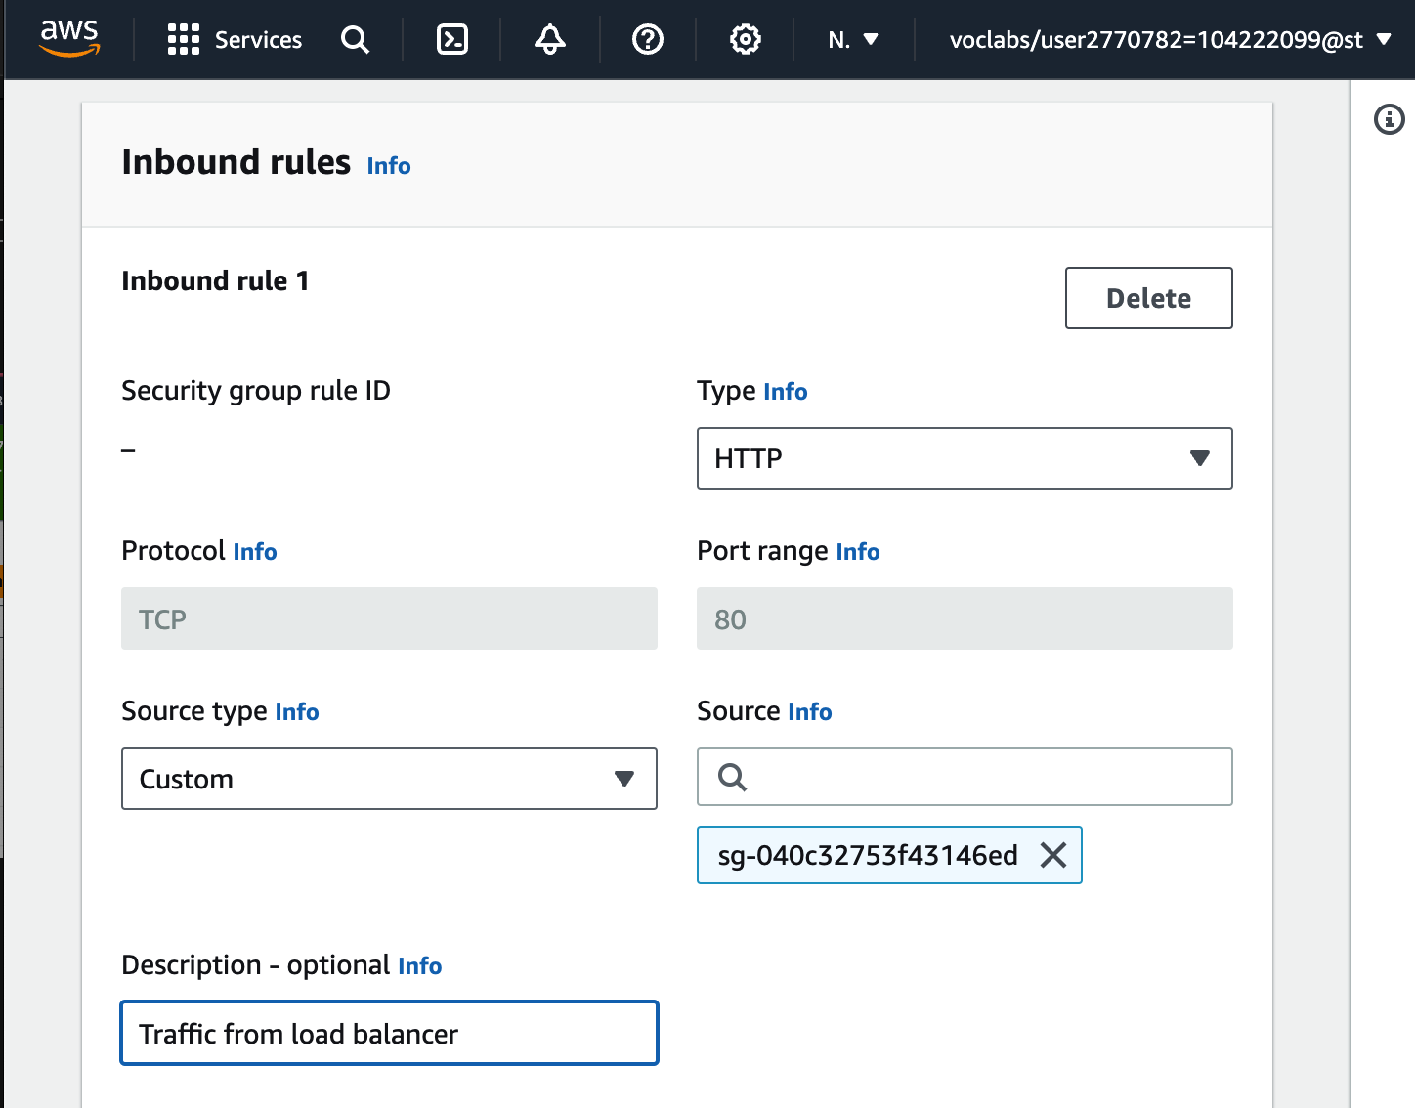

**Database security group**

In the **Security groups** list, choose **Inventory-DB** (and make sure that no other security groups are selected).

In the **Inbound rules** tab, choose Edit inbound rules and configure these settings:

* **Delete** the existing rule.
* Choose **Add rule**.
* For **Type**, choose **MYSQL/Aurora**
* Choose the search box to the right of **Custom**
* Enter sg
* From the list that appears, select **Inventory-App**
* **Description:** Traffic from application servers
* Choose Save rules

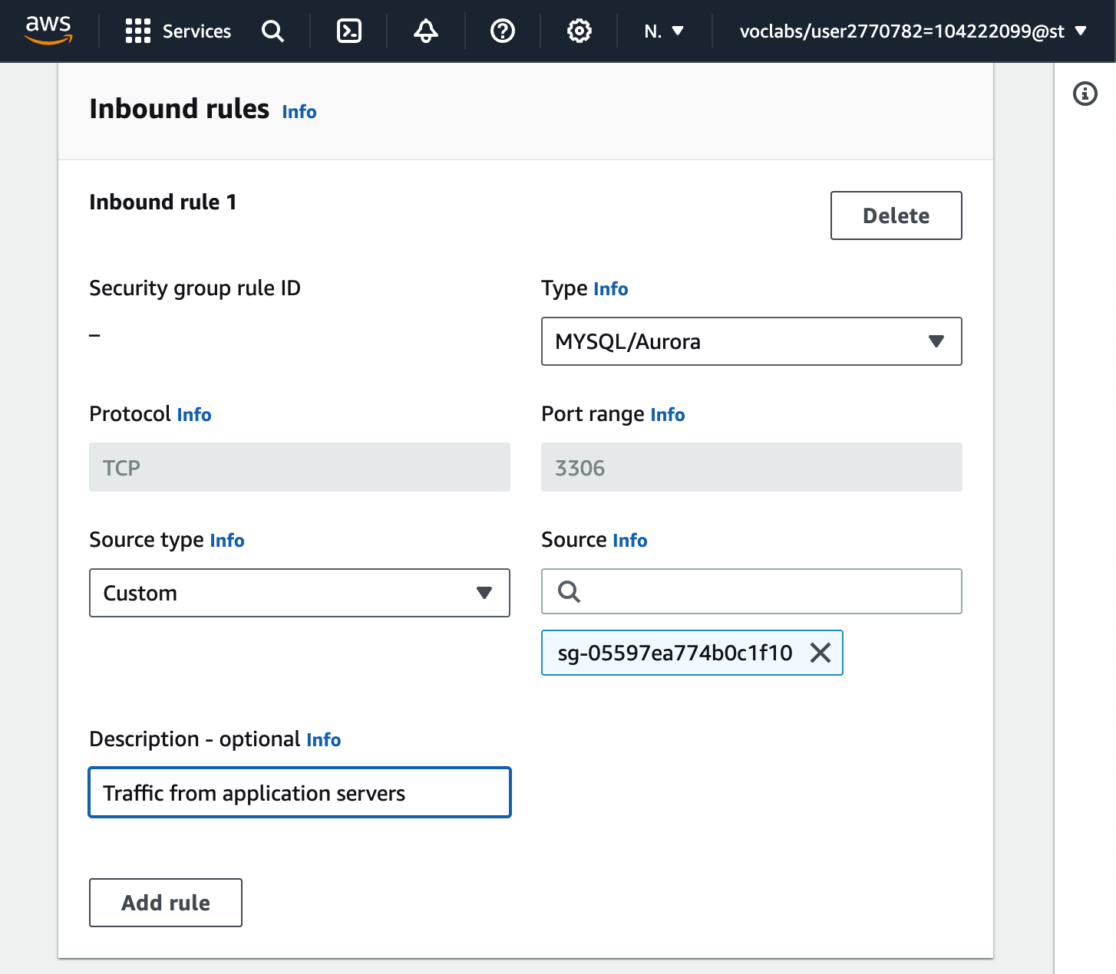

**Task 5: Testing the application**

In the left navigation pane, choose **Target Groups**.

Select **Inventory-App**.

In the lower half of the page, choose the **Targets** tab.

In the **Registered targets** area, occasionally choose the refresh icon until the **Status** for both instances appears as *healthy*.

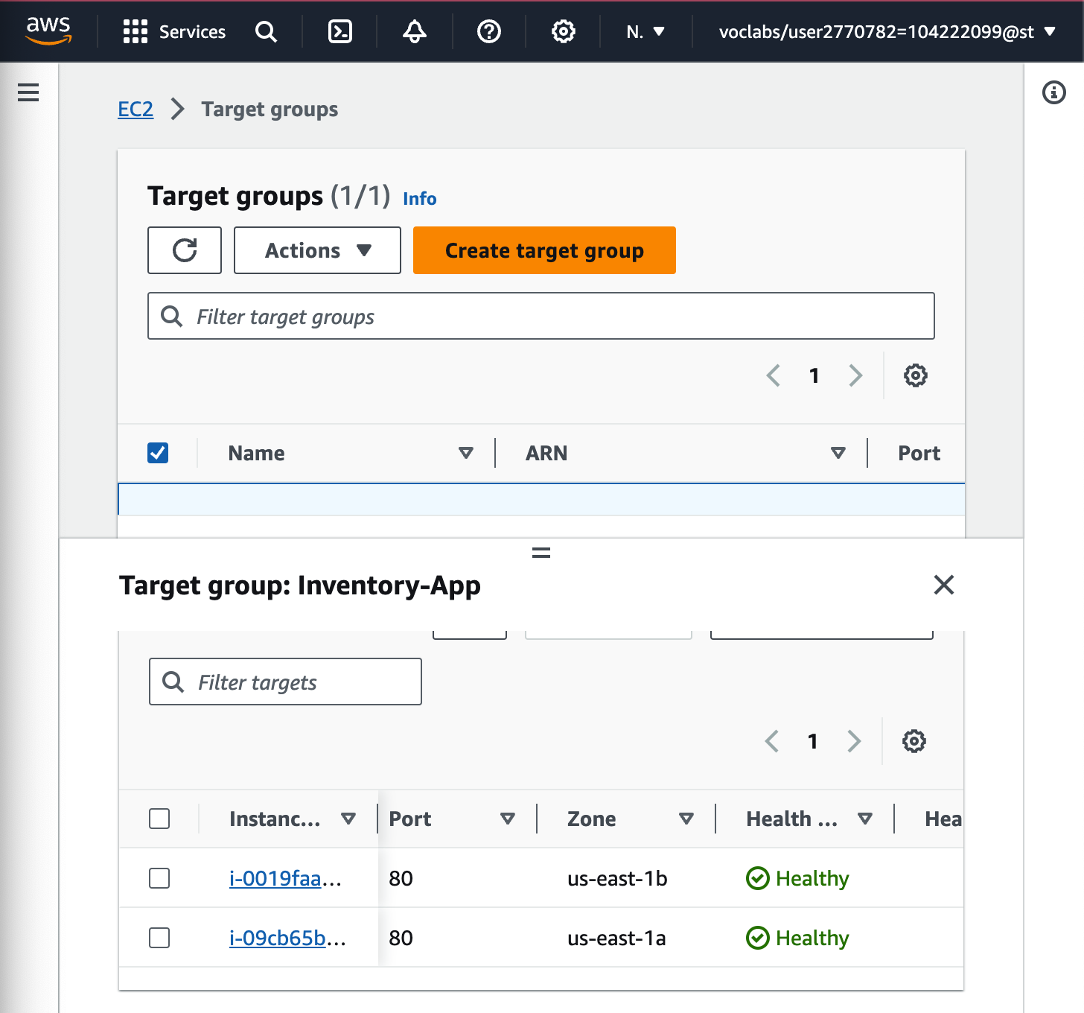

In the left navigation pane, choose **Load Balancers** and then choose **Inventory-LB**.

In the **Details** tab in the lower half of the window, copy the **DNS name** to your clipboard.

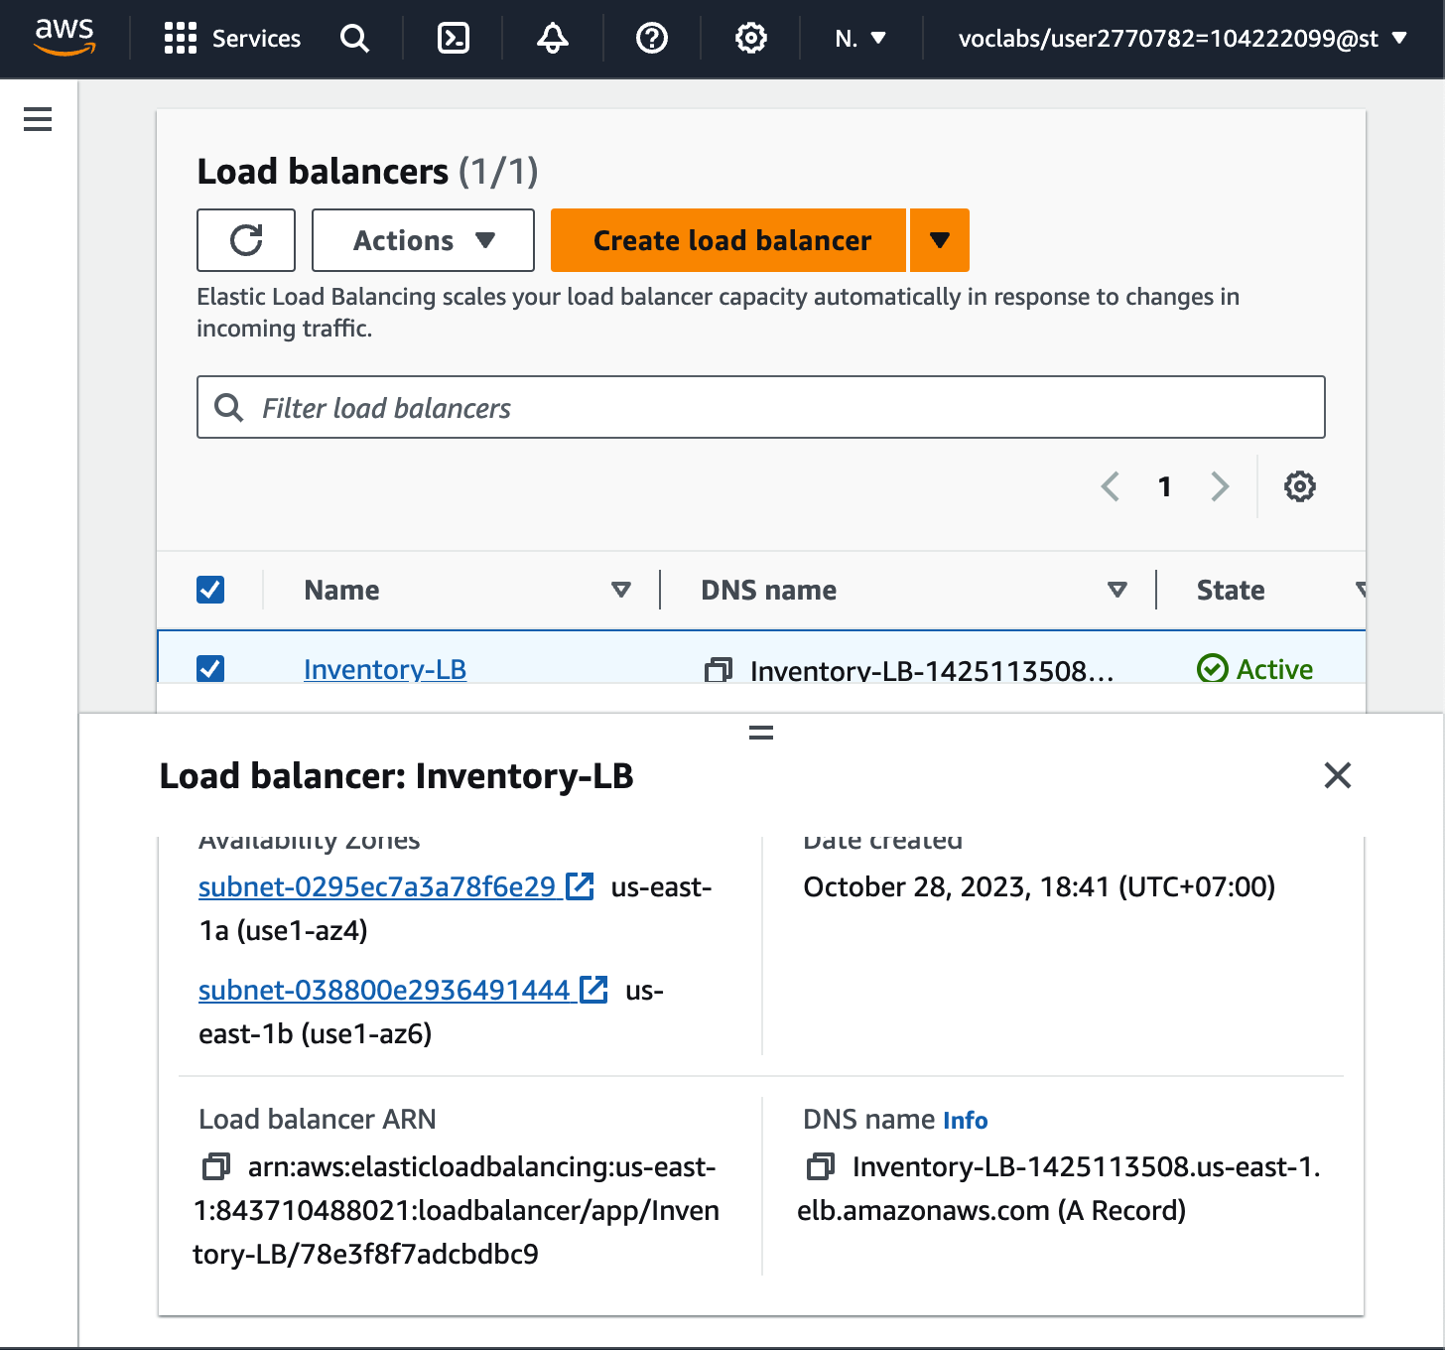

Open a new web browser tab, paste the DNS name from your clipboard and press ENTER.

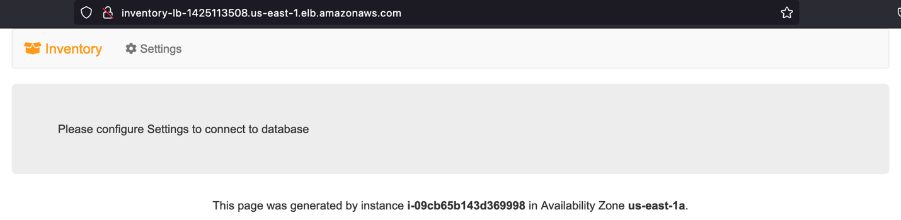

Reload the page in your web browser. You should notice that the instance ID and Availability Zone sometimes toggles between the two instances.

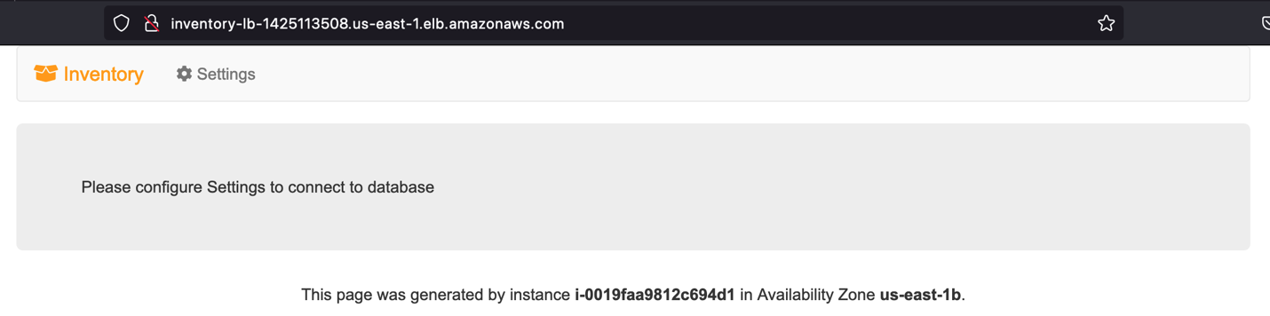

**Task 6: Testing high availability**

Return to the **EC2 console** tab in your web browser (but do not close the web application tab—you will return to it soon).

In the left navigation pane, choose **Instances**.

Select one of the **Inventory-App** instances

Choose **Instance State > Terminate instance** **>** **Terminate**.

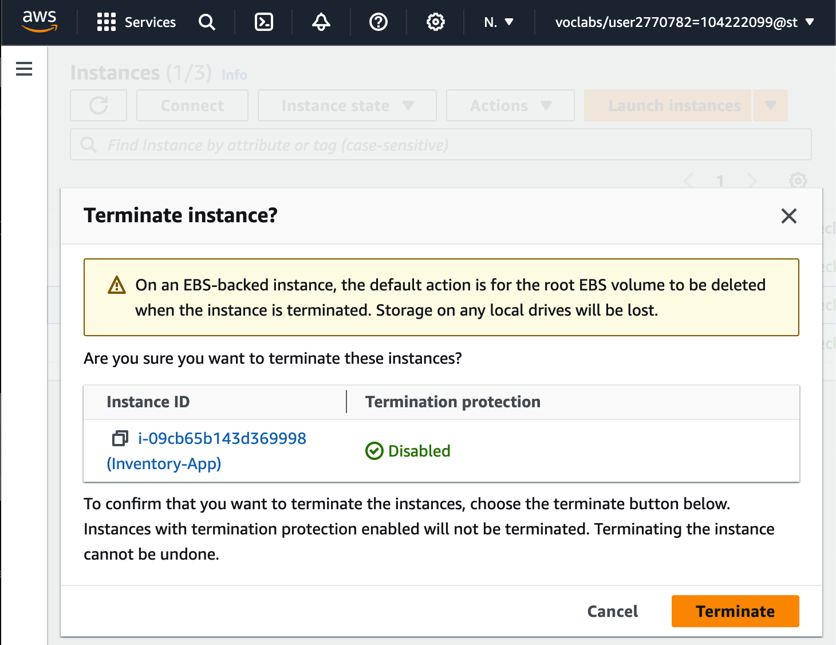

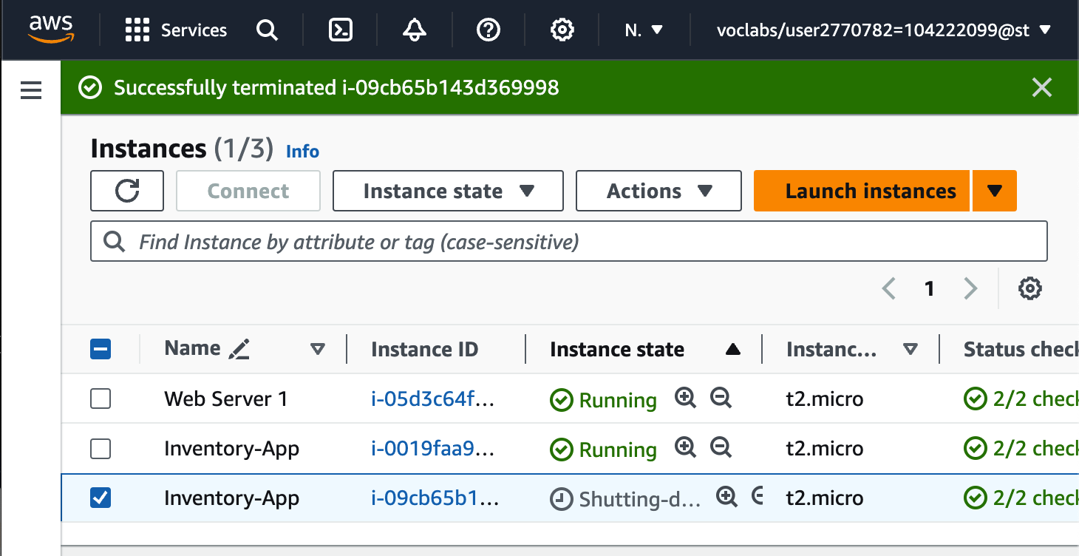

Return to the web application tab in your web browser and reload the page several times.

*Availability Zone* that is shown at the bottom of the page stays the same.

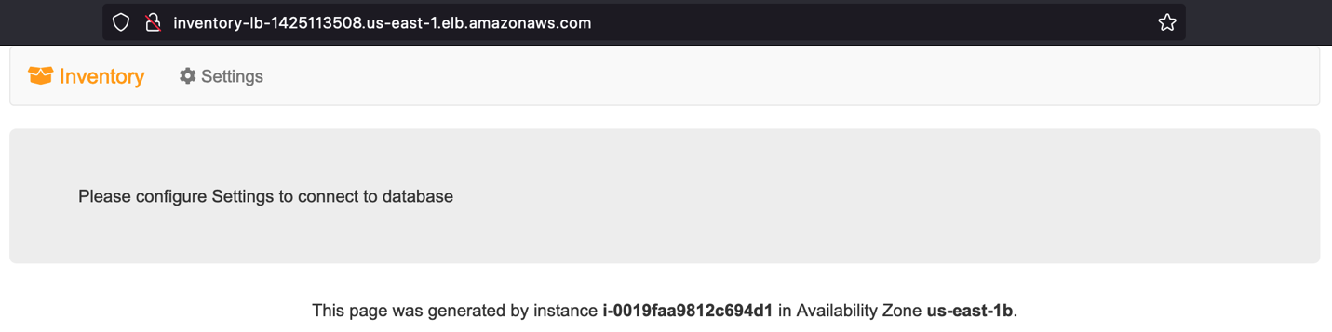

Return to the **EC2 console** tab where you have the instances list displayed. In the top-right area, choose the refresh icon every 30 seconds or so until a new EC2 instance appears.

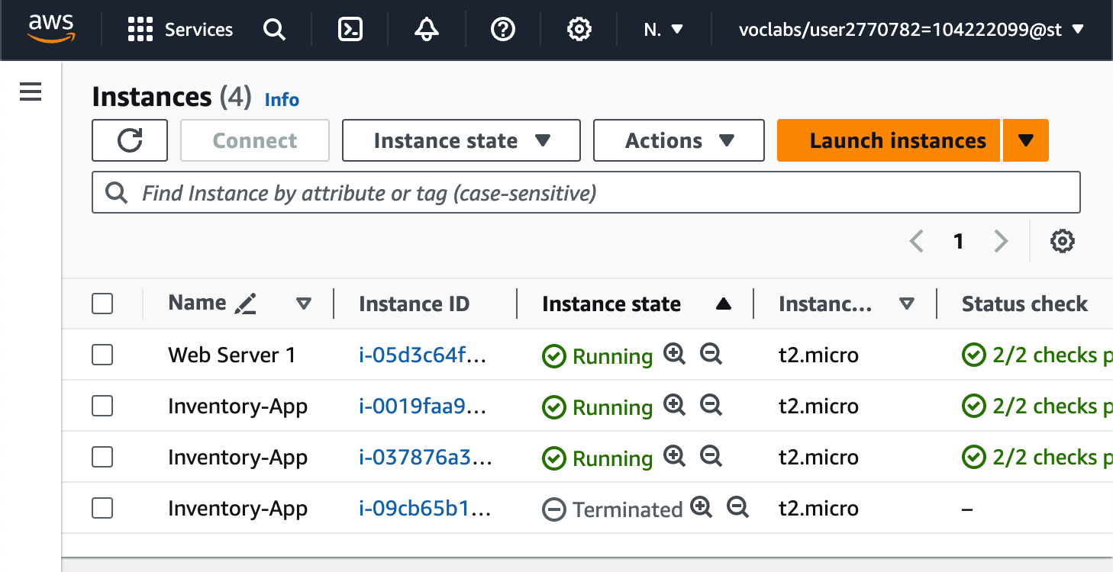

**Optional task 1: Making the database highly available**

On the Services menu, choose **RDS**.

In the left navigation pane, choose **Databases**.

Choose the link for the name of the **inventory-db** instance.

Choose Modify

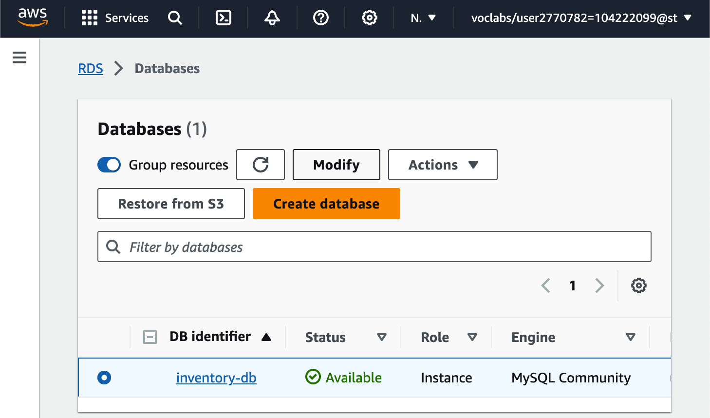

Scroll down to the **Availability & durability** section. For **Multi-AZ deployment**, select **Create a standby instance**.

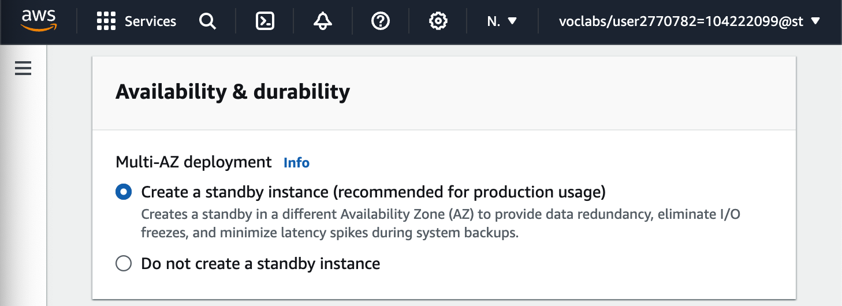

Scroll back up and for **DB instance class**, select **db.t3.small**.

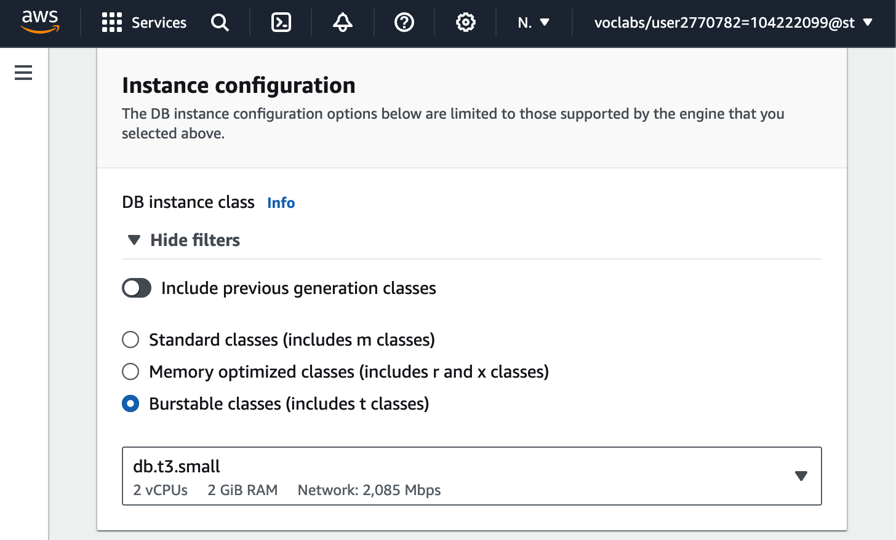

For **Allocated storage**, enter: 10

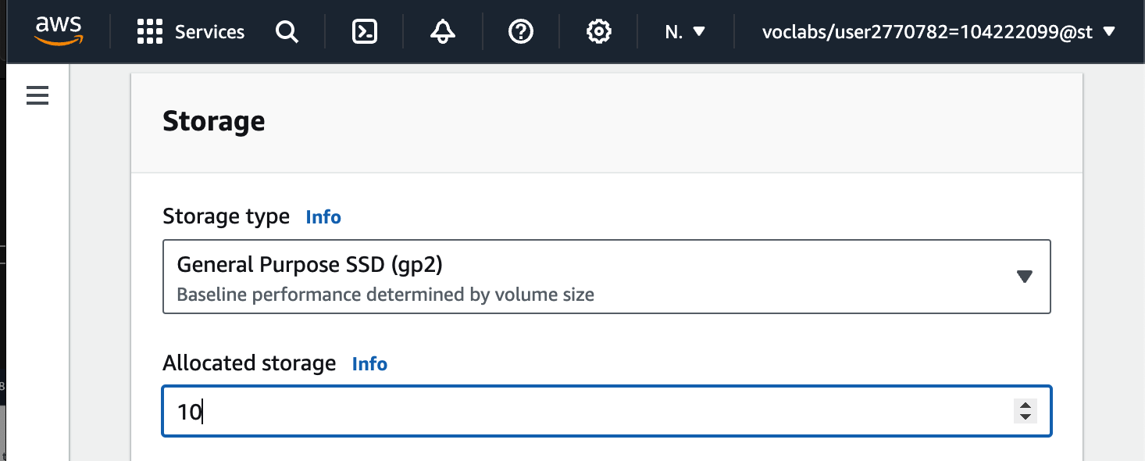

At the bottom of the page, choose Continue

Under **Schedule modifications**, select **Apply immediately**.

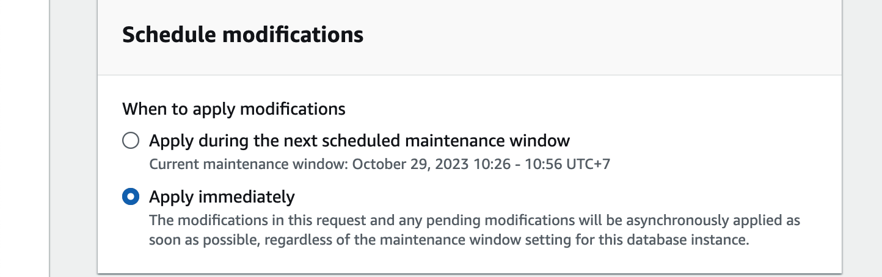

Choose Modify DB instance

**Optional task 2: Configuring a highly available NAT gateway**

On the Services menu, choose **VPC**.

In the left navigation pane, choose **NAT gateways**.

Choose Create NAT gateway and configure these settings:

* **Subnet:** *Public Subnet 2*
* Choose Allocate Elastic IP
* Choose Create NAT gateway

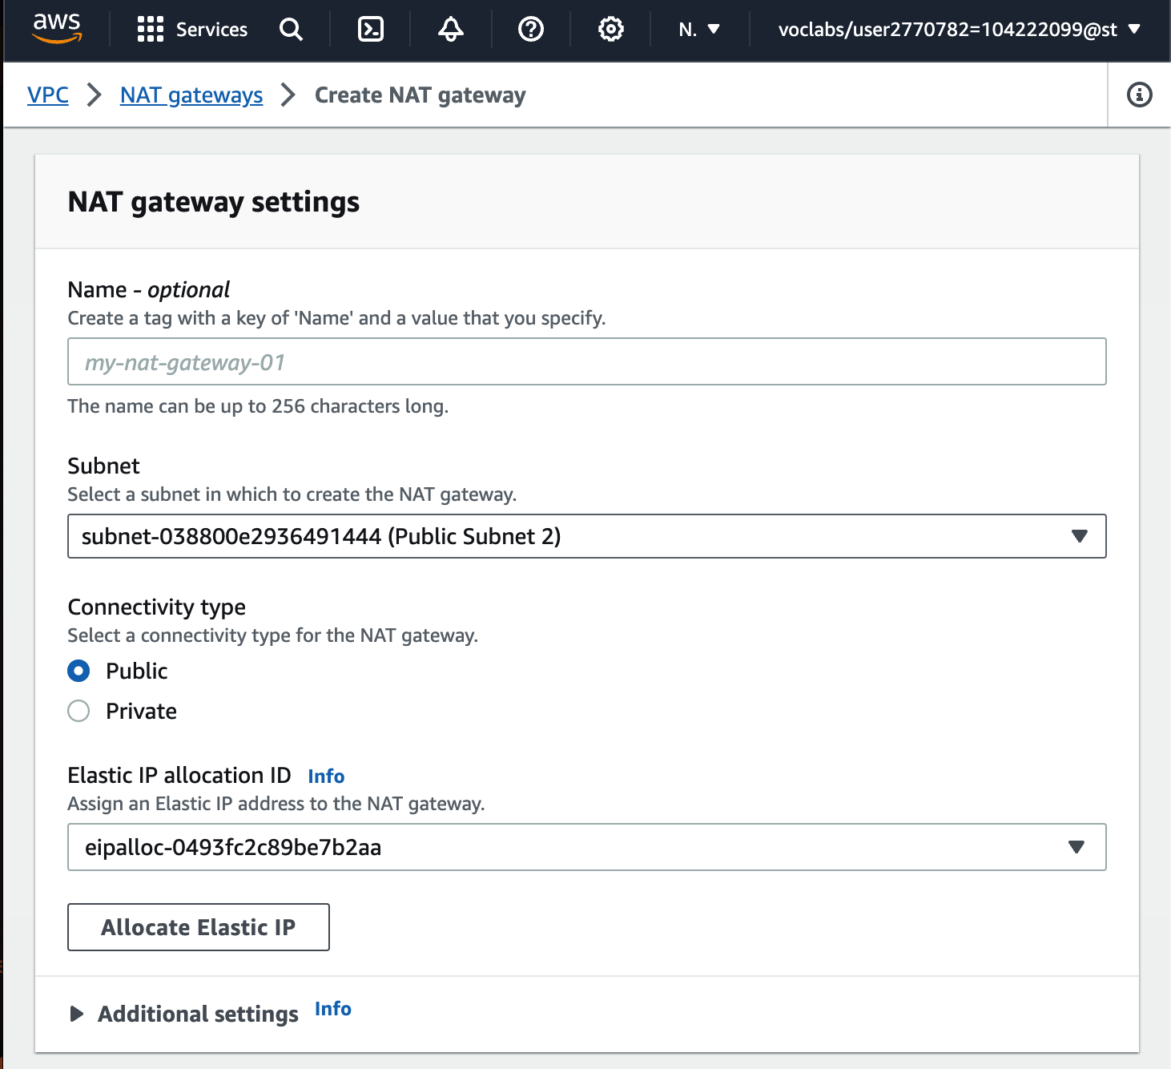

In the left navigation pane, choose **Route tables**.

Choose Create route table and configure these settings:

* + **Name:** Private Route Table 2
  + **VPC:** *Lab VPC*
  + Choose **Create route table**.

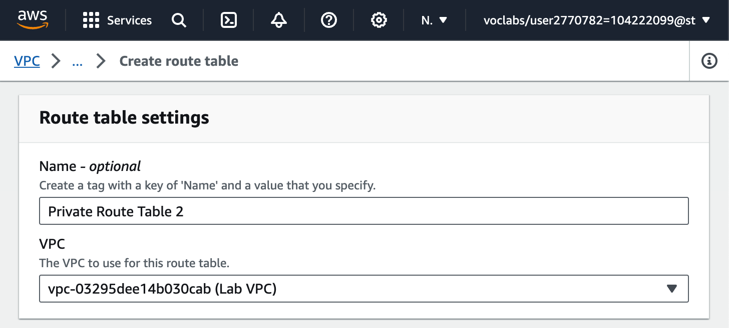

Observe the settings in the **Routes** tab.

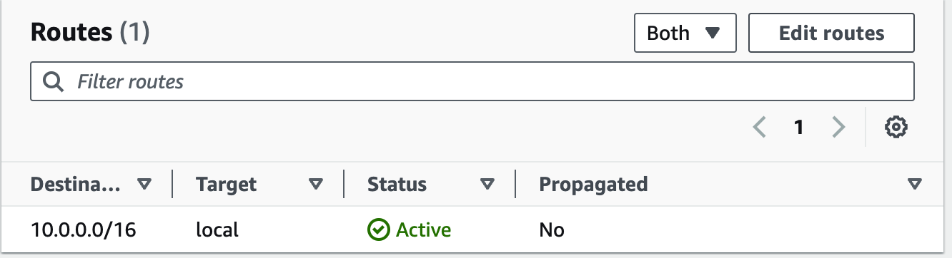

Choose Edit routes and then configure these settings:

* Choose Add route
* **Destination:** 0.0.0.0/0
* **Target:** Select *NAT Gateway*, then select the *nat-* entry that is *not* the entry for _NATGateway1

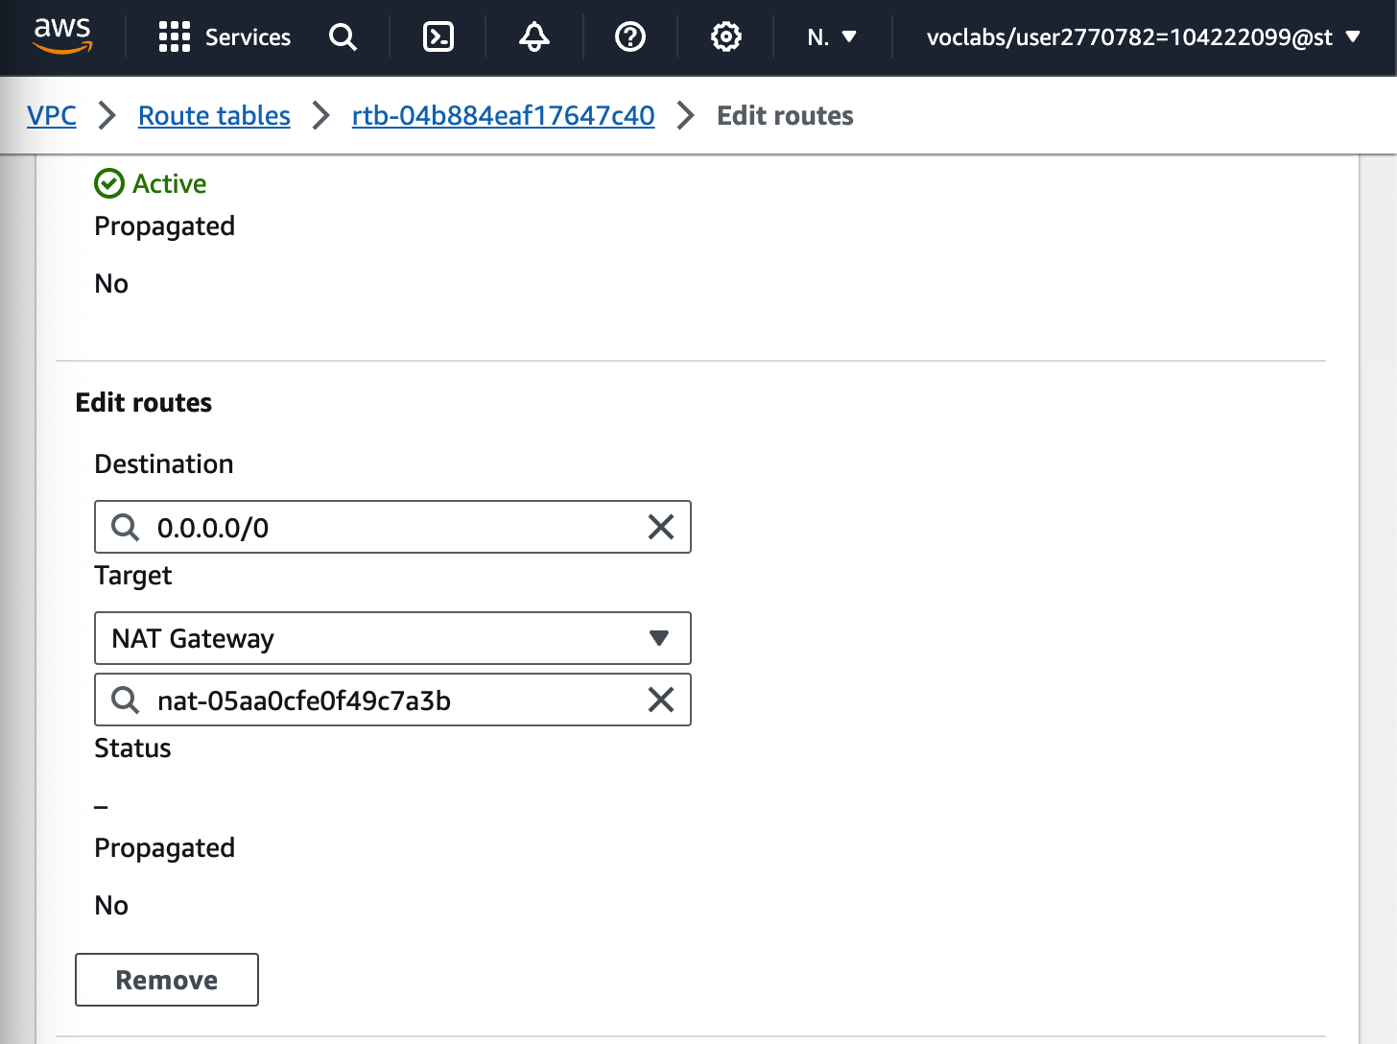

Choose Edit subnet associations

Select **Private Subnet 2**.

Choose Save associations

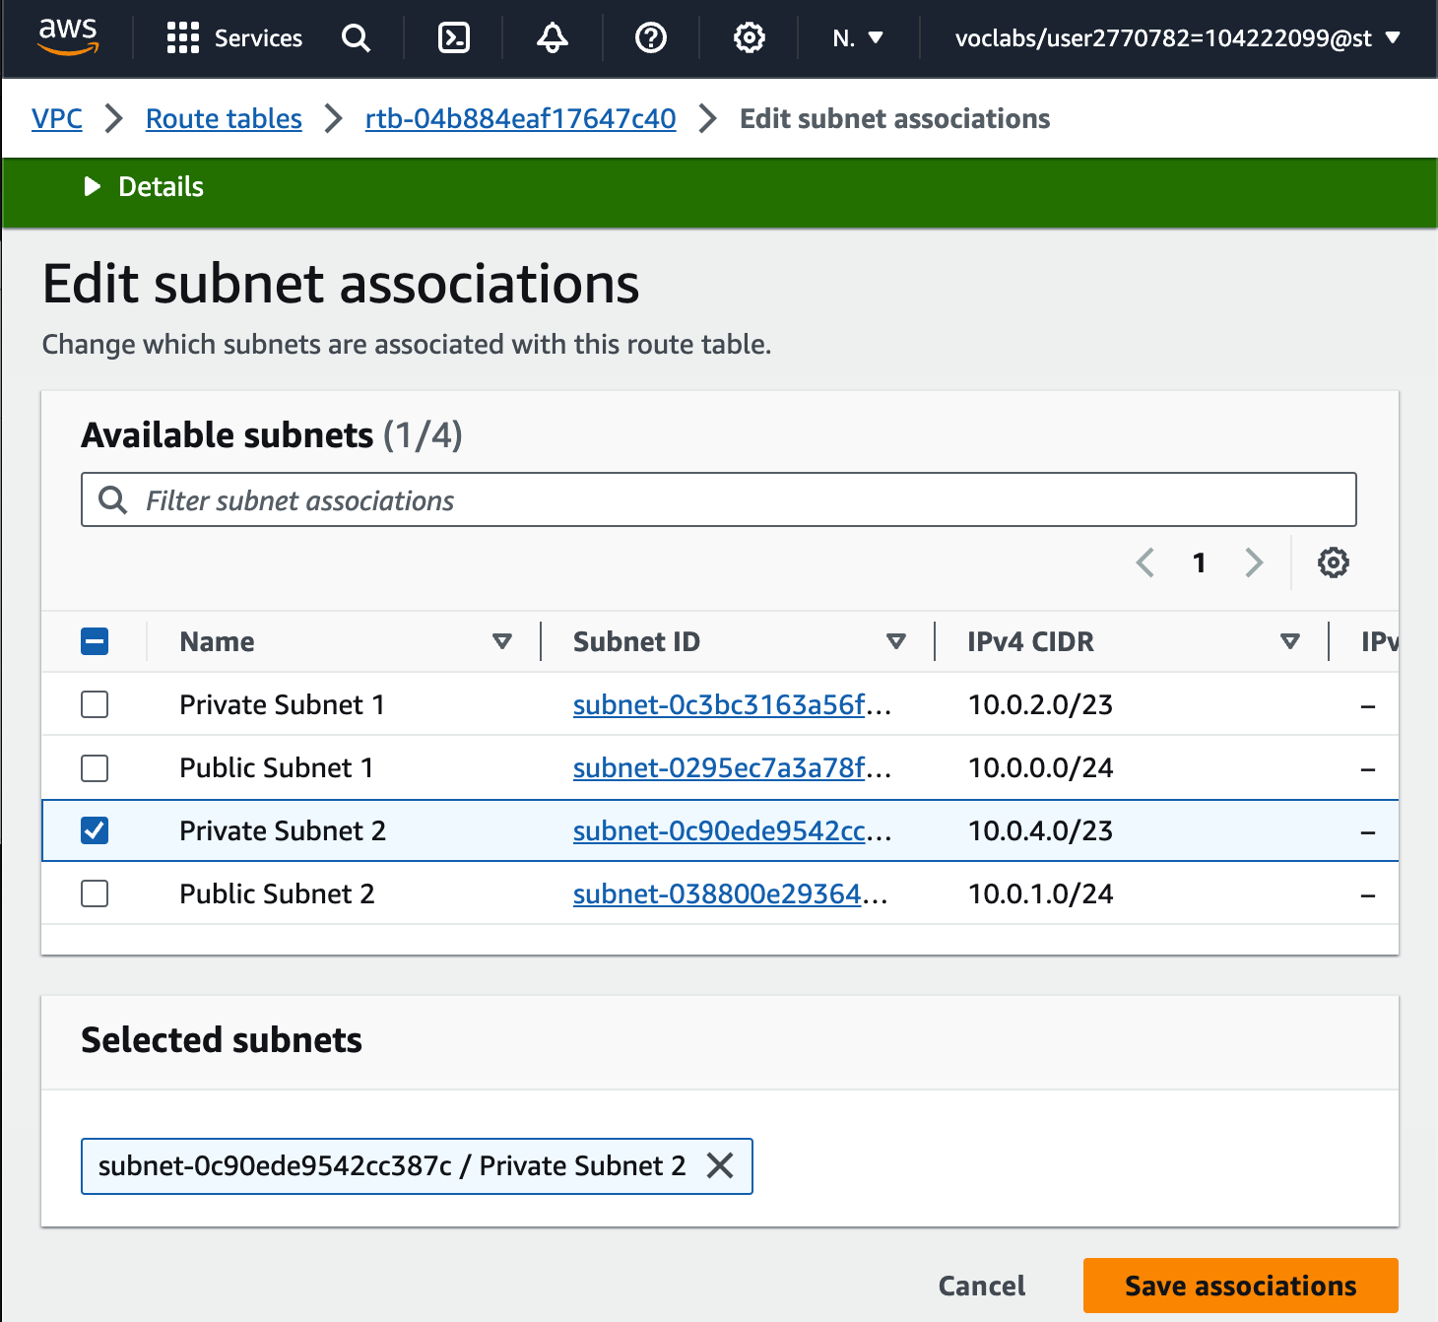

Submit the lab.

ENDLAB.